DIVERSITY AND ABUNDANCE OF GREEN SEAWEED Caulerpa (Chlorophyta) ACROSS INDONESIAN COASTAL WATERS WITH DIFFERENT NUTRIENT LEVELS: Bintan Island, Jepara, and Osi Island

KERAGAMAN DAN KELIMPAHAN RUMPUT LAUT HIJAU Caulerpa (Chlorophyta) DI PERAIRAN PESISIR INDONESIA DENGAN KANDUNGAN NUTRIEN YANG BERBEDA: Pulau Bintan, Jepara, dan Pulau Osi

Muhamad Darmawan¹, Neviaty P. Zamani^{2*}, Hari Eko Irianto³, & Hawis Madduppa²
¹Graduate School of Marine Sciences, IPB University, Bogor, 16680, Indonesia
²Department of Marine Science and Technology, Faculty of Fisheries and Marine Sciences, IPB University, Bogor, 16680, Indonesia
³National Research and Innovation Agency, Jakarta, Indonesia
*E-mail: neviaty@apps.ipb.ac.id

ABSTRACT
The green seaweed Caulerpa can be found in almost every coastal area of Indonesia, and it is one of the seaweeds with immense potential to be developed in the future. The chemical factors, especially water nutrients (nitrate, nitrite, phosphate, and ammonia), play an essential role in the distribution and diversity of seaweed. This study aimed to identify the abundance, ecological index, and relationship between the water column nutrients concentration and the biodiversity of Caulerpa from three different locations (Bintan Island, Jepara, and Osi Island). There were 12 points of observation at each site. The result showed a correlation between the nutrient levels and the abundance and diversity of Caulerpa in three locations. The nitrate, ammonia, and DIN:P ratio values were significantly different between areas. In contrast, there were insignificant differences in nitrite and phosphate concentrations between sites. The highest nitrate and phosphate concentrations were observed on Osi Island. The nitrite and ammonia values were identical for the condition on Bintan Island. The nitrate value was the main characteristic that distinguished the water nutrient at all sites. The Caulerpa species found in this research were Caulerpa racemosa, Caulerpa lentilifera, Caulerpa serrulata, Caulerpa sertularoides, and Caulerpa cupresoides. The nitrate and phosphate values influenced the growth factor of the green seaweed Caulerpa lentilifera. Caulerpa racemosa and Caulerpa serrulata, on the other hand, grew in response to ammonia levels. Caulerpa cupresoides diversity and abundance were impacted by the nitrite value. The results of the canonical correspondence analysis revealed that nitrate, phosphate, and ammonia were the most important factors influencing Caulerpa distribution in three locations.

Keywords: Caulerpa, ecological, green algae, biodiversity

ABSTRAK
Rumput laut hijau Caulerpa dapat ditemukan di setiap daerah pesisir Indonesia, dan merupakan salah satu rumput laut dengan potensi besar untuk dikembangkan di masa depan. Parameter kimia, terutama konsentrasi nutrisi di kolom perairan (nitrat, nitrit, fosfat, dan amonia), memainkan peran penting dalam distribusi dan keanekaragaman rumput laut. Penelitian ini bertujuan untuk mengidentifikasi kelimpahan, indeks ekologi, dan hubungan antara konsentrasi nutrisi di kolom perairan dengan keanekaragaman Caulerpa dari tiga lokasi yang berbeda (Pulau Bintan, Jepara, dan Pulau Osi). Hasil penelitian menunjukkan bahwa terdapat korelasi antara kadar nutrisi di perairan dengan kelimpahan dan keanekaragaman Caulerpa di tiga lokasi. Kadar nitrat, amonia, dan rasio DIN:P berbeda secara signifikan berbeda di semua lokasi. Namun demikian, kadar nitrit dan fosfat tidak berbeda secara signifikan di ketiga lokasi. Kadar nitrat dan fosfat tertinggi ditemukan di Pulau Osi. Kadar nitrit dan amonia mencirikan kondisi yang ada di Pulau Bintan. Kadar nitrat merupakan karakteristik utama yang membedakan nutrisi perairan di semua lokasi. Spesies Caulerpa yang ditemukan pada penelitian ini adalah Caulerpa racemosa, Caulerpa lentilifera, Caulerpa serrulata, Caulerpa sertularoides, dan Caulerpa cupresoides. Faktor pertumbuhan rumput laut hijau Caulerpa lentilifera dipengaruhi oleh kadar nitrat dan fosfat. Di sisi lain, kadar amonia menentukan pertumbuhan Caulerpa racemosa dan Caulerpa serrulata. Keragaman dan kelimpahan Caulerpa cupresoides dipengaruhi oleh kadar nitrit. Hasil analisis korespondensi kanonik menunjukkan bahwa parameter nitrat, fosfat, dan amonia menjadi parameter dominan yang mempengaruhi distribusi Caulerpa di tiga lokasi.

Kata Kunci: Caulerpa, ekologi, rumput laut hijau, keanekaragaman

INTRODUCTION

Green seaweed from the genus Caulerpa is one type of seaweed found in various regions of the world. The vast spread of marine green algae Caulerpa covers tropical and sub-tropical areas (Darmawan et al., 2020; Rushdi et al., 2020) and has expanded its coverage range into more temperate regions (Famà et al., 2002). Genus Caulerpa can inhabit a wide area from intertidal to subtidal zones (Baleta & Nalleb, 2016) and grow in every type of substrate (muddy, sandy, or rocky) (de Gaillande et al., 2017). Nowadays, 173 species and 232 infraspecific have been published for the genus Caulerpa, with 104 species being accepted taxonomically (Guiry & Guiry, 2021). According to Atmadja and Prud’homme van Reine (2014), there are 32 different species of Caulerpa in Indonesia based on the morphological aspect.
Environmental conditions such as temperature, light, salinity, and nutrient concentration in the water are among the major factors that control the growth and spread of Caulerpa in several areas (Uyà et al., 2017; Chen et al., 2019; Alexandre & Santos, 2020). Some species from the genus Caulerpa became invasive and widespread in some areas of the world. Several Caulerpa species, known as invasive species, occupy extensive areas and could cause changes in the native ecosystem (Rizzo et al., 2017; Pereda-Briones et al., 2018; Alexandre & Santos, 2020) and damage the environment (Darmawan et al., 2020). The two most invasive species from the genus Caulerpa are Caulerpa taxifolia (Jousson et al., 1998; Bitar et al., 2017; Gribben et al., 2017; Mannino & Balistreri, 2017) and Caulerpa racemosa var. cylindracea or Caulerpa cylindracea (Gartner, 2005; Žuljević et al., 2012; Mannino & Balistreri, 2017; Rizzo et al., 2017) which has invaded many areas, mainly in the Mediterranean Sea.
In Southeast Asia, Caulerpa can be found in Philippine, Indonesia, Vietnam, and Malaysia (Chen et al., 2019; Dumilag et al., 2019; Lapong et al., 2019; Aroyehun et al., 2020; Gao et al., 2020). Caulerpa has been utilized as food and consumed broadly in the Indo-pacific region, especially in the Southeast Asia region (Lapong et al., 2019), and is well known as nutritious food in Japan, Korea, and Southeast Asia countries (Darmawan et al., 2020). Some of the Caulerpa species, like C. racemosa, are traditionally consumed as salad or vegetables by the locals in Southeast Asian countries like Indonesia, Malaysia, and the Philippines (Fithriani, 2015; Aroyehun et al., 2020). As a part of that, this green seaweed is also used as medicine since ancient times in the Indo-Pacific region (Aroyehun et al., 2020).
Green seaweed Caulerpa can be used as raw materials for nutraceutical and pharmaceutical products. Caulerpa has a high nutritional value and is beneficial for the medical field such as polysaccharides, amino acid and protein content, polyunsaturated fatty acids (PUFAs), mineral content, vitamin, and pigment content (Matanjun et al., 2009; Rodrigues et al., 2012; Paul et al., 2014; Ribeiro et al., 2014; Alam Bhuiyan & Qureshi, 2016; de Gaillande et al., 2017). Various bioactive compounds of the genus Caulerpa have been widely studied and reported for numerous pharmacological properties (Darmawan et al., 2020). The presence of natural bioactive compounds in Caulerpa has contributed to its antibacterial, anticancer, antidiabetic, and larvicidal activity (Nagaraj & Osborne, 2014; Sharma et al., 2015; Qian et al., 2016; Rizzo et al., 2017; Mehra et al., 2019).
Genus Caulerpa is one of the genera in the green seaweed with a high number of species found in Indonesia. Some researchers have already identified the presence of Caulerpa in Indonesian Territory such as in Bali (Indrawati et al., 2012), Maluku (Arfah & Patty, 2014), North Sulawesi (Pulukadang et al., 2013; Tampubolon et al., 2013; Kepel et al., 2020), Southeast Sulawesi (Irwandi et al., 2017), Lampung (Handayani, 2017), Jakarta (Marianingsih et al., 2013; Wulandari et al., 2020; Zulpikar et al., 2020), and Central Java (Widyartini et al., 2021). Most of the research explained the existence of Caulerpa species in the region and other seaweed species. The location of samples discussed in the study was usually very limited only to one site. Information about the abundance, the community structure, and the relationship between the environmental factors with the green seaweed Caulerpa from several regions in Indonesia is still rare to find. This research objective was to identify the abundance, the ecological index of seaweed Caulerpa, and the relationship between the nutrient concentration (ammonia, nitrite, nitrate, and phosphate) with the biodiversity of green algae from the genus Caulerpa from three different sites (Jepara, Central Java; Bintan Island, Kepulauan Riau; Osi Island, Maluku). This study hypothesizes a correlation between nutrient levels, seaweed abundance, and diversity in three locations. This research can be used as scientific information for further management and utilization of green seaweed Caulerpa in Indonesia.

MATERIALS AND METHODS

Study Site and Data Collection
This study was conducted from October 2018 – September 2019 in three different locations in Indonesian waters, namely in Bintan Island (Kepulauan Riau Province), Jepara (Central Java Province), and Osi Island (Maluku Province) (Figure 1). Based on the observation, the substrates differed for each sampling site: sandy in Bintan Island; sandy and rocky in Jepara; sandy, rocky, and muddy in Osi Island.
The sampling locations in each site were determined using the Purposive sampling method. This study used the line transect method (English et al., 1997). There was one sampling station in each location. The stations were divided into three different substations as replications with a distance of 50-100 meters for each substation. The substations were divided into four different

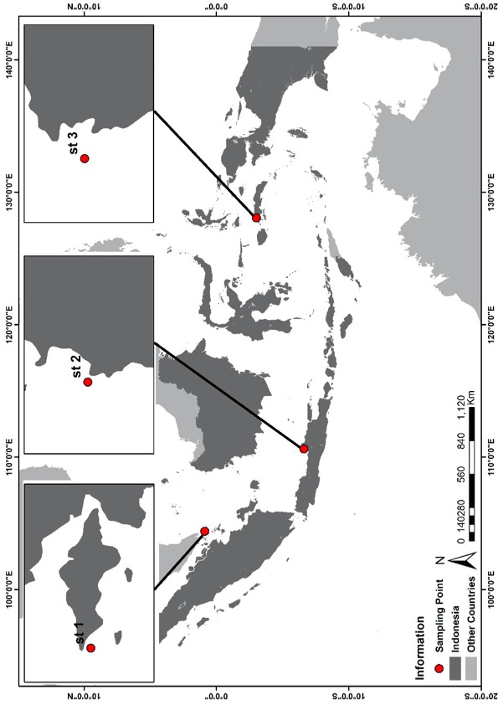
Bintan Island
Osi Island
Jepara

Figure 1. Map of study sites in Bintan Island, Jepara, and Osi Island

points of observation with a distance of 25 meters. At each observation point, a quadratic transects with a size of (50 x 50) cm² was placed with a total of 12 transects for each location. All samples were collected during the lowest tidal level with a depth of 30 – 100 cm. The information collected from each sampling site was Caulerpa species identifications, the number of individuals or abundance of individuals, and the water nutrient parameters. Identification of seaweed samples was carried out following Anggadiredja et al. (2006) and Kalasariya (2019). Determination of the individual’s seaweed found in the transect was carried out by counting each seaweed stand. Water samples were collected using a 1 L polyethylene bottle with a range of 50-80 cm from the surface and stored at 4ºC in a cool box. Marine water samples were preserved using the American Public Health Association procedures (APHA, 2005). The nutrient analysis of seawater consisting of nitrite, nitrate, phosphate, and ammonia was measured using a portable data logging colorimeter type HACH DR-890.

Data Analysis
The Preliminary statistical test was performed not only to check for the normality of data (Shapiro-Wilk test of normality data) but also to evaluate homoscedasticity of the data. The difference between seawater nutrient values in each sampling site was tested using the non-parametric test (Kruskal-Wallis). Kruskal-Wallis test was performed because the assumption of normality data for the ANOVA test was not fulfilled after the preliminary test. Seawater nutrient values were log (x+1) transformed and seaweed diversity in the square root for multivariate analysis. The relationship between the seawater nutrient characteristic in each sampling site was determined using principal component analysis (PCA). The Preliminary statistical test, the Kruskal-Wallis, the Dunn, and PCA tests were conducted using R Studio (v1.1.419) (Kassambra, 2017). The abundance index is ﻿the ratio between individuals of species i in a unit of (m²) (Sumandiarsa et al., 2020). One-way ANOVA was performed to measure the significance of seaweed abundance in three locations. The ecological index consists of Shannon-Wienner diversity index (H’), Evenness index (E), and dominance index (C) were calculated using Bengen (2000). The relationship between the multi-variable (seawater nutrient values and seaweed diversity) was tested using multivariate canonical correspondence analysis (CCA). The CCA was performed with PAST Statistical Software V4.02 (Hammer, 2020).

RESULT AND DISCUSSION

Results

3.1.1. Seawater Nutrient Values
The result of seawater nutrients in three different locations showed a variation for each component (nitrite, nitrate, phosphate, and ammonia) (Table 1). The nitrite and phosphate values tended to be

Table 1. Mean Seawater Nutrient variation in Osi Island, Bintan Island, and Jepara

Location | Nitrite (mg L⁻¹) | Nitrate (mg L⁻¹) | Phosphate (mg L⁻¹) | Ammonia (mg L⁻¹) | DIN:P Ratio
Osi Island | 0.003 ± 0.001 | 5.001 ± 0.707 | 0.099 ± 0.610 | 0.000 ± 0.000 | 50.47:1
Bintan Island | 0.005 ± 0.020 | 1.400 ± 0.005 | 0.070 ± 0.027 | 0.185 ± 0.391 | 22.83:1
Jepara | 0.004 ± 0.001 | 1.772 ± 0.360 | 0.058 ± 0.140 | 0.012 ± 0.160 | 31.10:1

similar for all three areas. Meanwhile, the nitrate and ammonia values showed differentiation in all three sites. Osi island had a high nitrate value, while Bintan Island had a higher ammonia value.
The Kruskal-Wallis test of seawater nutrient levels in the three locations showed a significant difference for nitrate (p = 0.0000001), ammonia (p = 0.00003), and DIN:P ratio (p = 0.000009) parameters. On the other hand, nitrite and phosphate showed insignificant differences (p = 0.27 and p = 0.48). The post hoc test using the Dunn test has shown that nitrate values from three sites were significantly different (p < 0.05), and the ammonia values differences were only observed between Osi Island and Bintan Island (p < 0.05) (Figure 1). Based on the

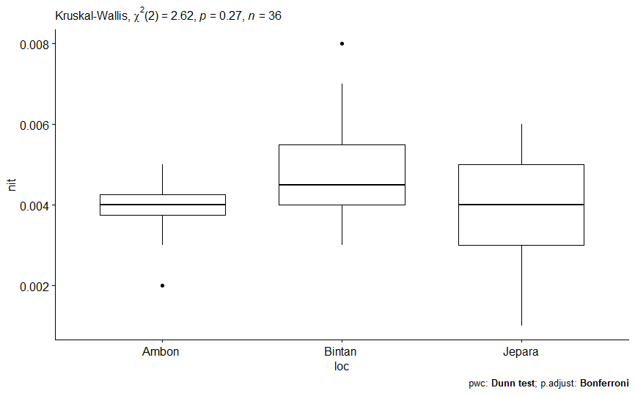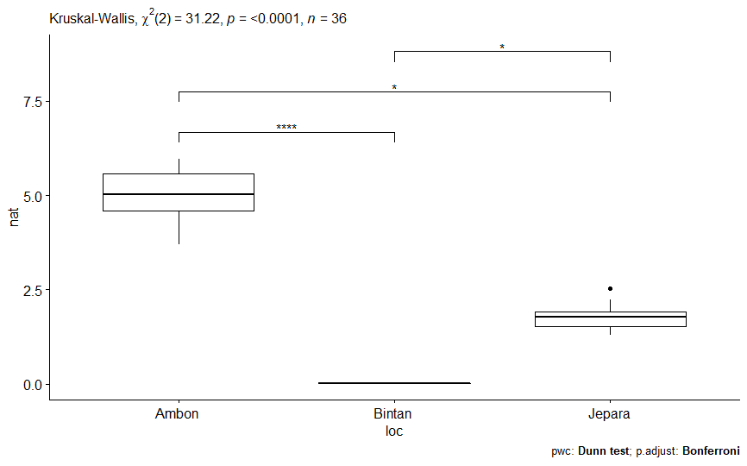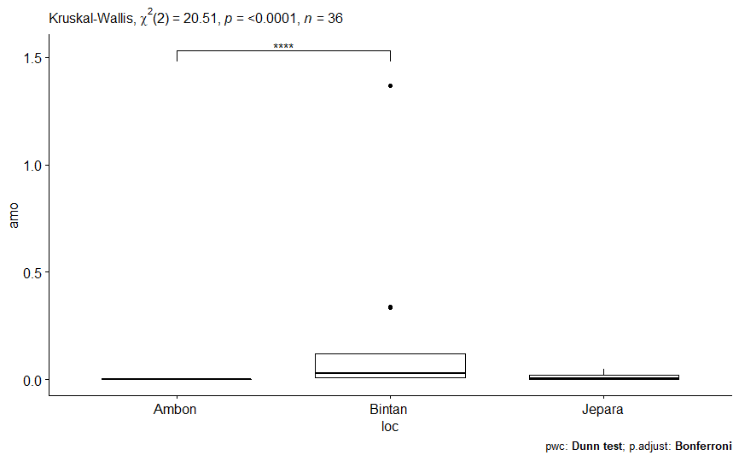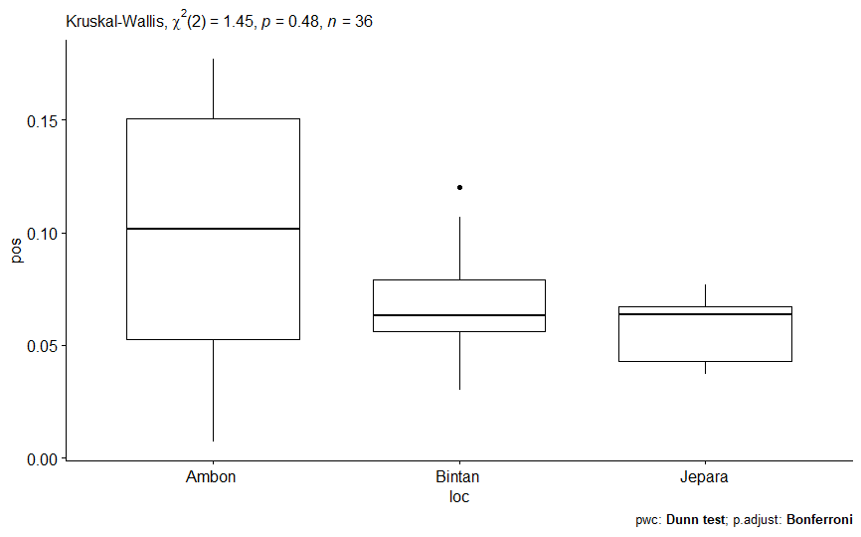
Location
Nitrite (mg L⁻¹)
Osi Island
Bintan Island
Jepara
(a)
Location
Nitrate (mg L⁻¹)

(b)
Osi Island
Bintan Island
Jepara
(d)
Osi Island
Bintan Island
Location
Ammonia (mg L⁻¹)

(c)
Osi Island
Bintan Island
Jepara
Location
Phosphate (mg L⁻¹)

Jepara
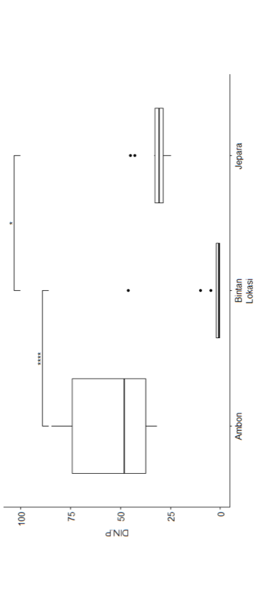
Location
Osi Island
Bintan Island
Jepara
(e)
DIN:P

Figure 1. Kruskal-Wallis test result on seawater nutrients in Osi Island, Bintan Island, and Jepara; (a) Nitrite, (b) Nitrate, (c) Phosphate, dan (d) Ammonia.; (e) DIN:P *) significant different
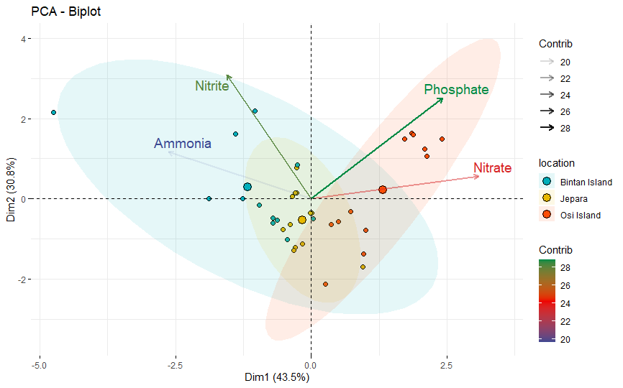

Figure 2. Principal Component Analysis (PCA) of seawater nutrient in Osi Island, Bintan Island, and Jepara.

ratio of Dissolved Inorganic Nitrogen (DIN) value with the phosphate Value (DIN: P), Osi Island has the highest water nutrients value. In contrast, the lowest water nutrient value was on Bintan Island.
PCA analysis of seawater nutrients in three locations showed that about 74.3% of the total variance was explained by two Principal Components (PC) (Figure 2). The first PC (PC 1) consisted of two different nutrient components: phosphate and nitrate. On the other hand, the second PC (PC 2) consisted of nitrite and ammonia components. Based on Figure 2, the characteristics of seawater nutrients in Osi Island tended to be in quadrants 1 and 4. Meanwhile, Bintan Island's characteristics of seawater nutrients tended to be in quadrants 2 and 3. In Jepara, the characteristics of seawater nutrients were found around the middle of the quadrant.
Osi Island was characterized by the high value of phosphate and nitrate. On the other side, Bintan Island had high nitrite and ammonia values. PC 1 showed that phosphate and nitrate had a close relationship, with a positive correlation between those two factors. PC 2 indicated that nitrite and ammonia positively correlated with each other.

3.1.2. Seaweed Abundance
The number of Caulerpa species found in three locations varied. Nevertheless, the one-way ANOVA test of seaweed abundance in the three locations showed an insignificant difference seaweed abundance (p>0.05). On Bintan Island and Osi Island, the number of species seen was only three species. In Osi Island, the species were Caulerpa racemosa, Caulerpa lentilifera, and Caulerpa serrulata. Meanwhile, on Bintan Island, the species were Caulerpa racemosa, Caulerpa cupresoides, and Caulerpa serrulata. The number of Caulerpa species found in Jepara was higher than in two other areas: Caulerpa racemosa, Caulerpa lentilifera, Caulerpa sertularoides, and Caulerpa serrulata (Figure 3). Two species can be found in all three locations, C. racemosa and C. serrulata. The highest abundance of C. racemosa was found in Bintan Island (148 ind m⁻²), and the lowest was in Jepara (124 ind m⁻²). On the other hand, a high abundance of C. serrulata was found in Jepara (104 ind m⁻²), and the lowest value was in Osi Island (28 ind m⁻²). Certain species only can be found in one location, such as C. cupresoides in Bintan Island (56 ind m⁻²) and C. sertularoides in Jepara (180 ind m⁻²). C. lentilifera was found in Osi island (64 ind m⁻²) and Jepara (52 ind m⁻²).

3.1.3. Ecological Index
The diversity index (H’) of all seaweed species from the genus Caulerpa in three locations is characterized as low to relatively abundant. On Osi island, the diversity index of green seaweed Caulerpa was low (H’ <1), while on Bintan Island and Jepara, the diversity index was relatively abundant (1 ≤ H’ ≤ 3). The Evenness index (E) of green seaweed Caulerpa in Osi Island
and Bintan Island was categorized in a depressed condition (0 < E ≤ 0.5). On the other hand, the uniformity index Caulerpa in Jepara island was unstable (0.5 < E ≤ 0.75). The dominance index (C) of Caulerpa in all three locations was categorized as low (0 < C ≤ 0.5), which means that there were no species that dominated the areas. The ecological index of the three locations can be seen in Figure 4.

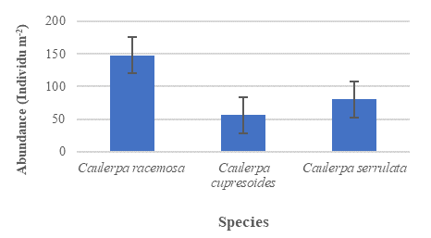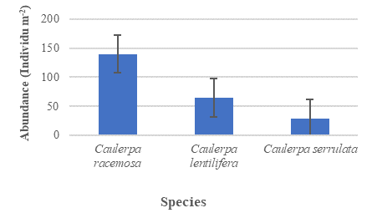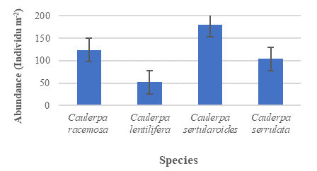
(a)
(c)
(b)

Figure 3. The abundance of green seaweed Caulerpa (individu/m²) in (a) Osi Island; (b) Bintan Island; and (c) Jepara

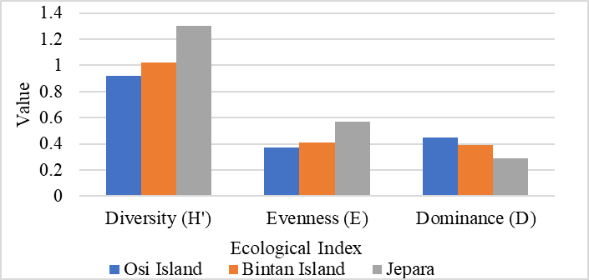

Figure 4. Ecological index of green seaweed Caulerpa in Osi Island, Bintan Island, and Jepara

3.1.4. Relationship between Seawater Nutrients and The Diversity of Seaweed
The canonical correspondence analysis showed that the seawater nutrient and the Caulerpa species could be found in different quadrants, indicating a correspondence pattern between the two factors (Figure 5). The interaction between seaweed diversity in three locations with the seawater quality is presented in Figure 5, with the eigenvalue of axis one was 0.19 or 81.97%, and axis two was 0.04 or 16.12%. Caulerpa cupresoides corresponded to high nitrite and ammonia components in Bintan Island and are in quadrant one of the dendogram. Caulerpa racemosa and Caulerpa serrulata corresponded to high ammonia components in Bintan Island (quadrant four). On the other hand, Caulerpa lentilifera corresponded to nitrate and phosphate components in Osi Island (quadrant three). Meanwhile, the poor condition of water nutrients in Jepara corresponded to the existence of Caulerpa sertularoides in quadrant two.

Discussion
The growth of seaweed is controlled by the water quality parameters such as nutrients, dissolved oxygen, depth, current speed, brightness, acidity, total dissolved solids, and total suspended solids (Sulistiawati et al., 2020). Nitrogen (N) and phosphorous (P) are the two essential nutrients limiting seaweed growth and yields (Roleda & Hurd, 2019; Suthar et al., 2019). Nitrogen and phosphorous accessibility in the ecosystem limit seaweed growth and regulate seaweed distribution and types of seaweed species, especially when light and temperature are not restricting (Genarro et al., 2015). Some research showed that the N:P ratio could determine seaweed's growth, abundance, and species composition (Guo et al., 2015; Harwanto et al., 2020). The N:P ratio in seawater at three locations varied from 22.83 :1 (Jepara) to 50.47: 1 (Osi Island). These

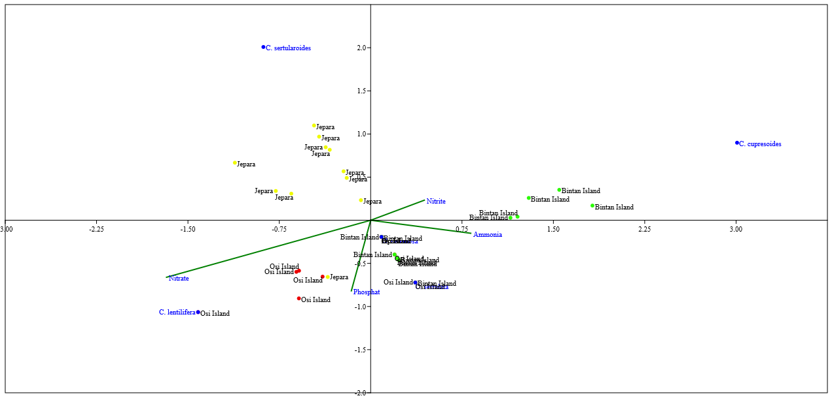

Figure 5. Canonical Correspondence Analysis (CCA) plot of the relationship between Caulerpa species and seawater nutrient parameters.

N:P ratios are still in the range of the optimum N:P ratio for seaweed. Suthar et al. (2019) mentioned that the optimal N: P ratio for seaweeds ranges from 10:1 to 80:1, although each species might have a different optimum ratio.
Atkinson & Smith (1983) stated that the optimum ratio of N:P for seaweed is 30:1, with a range from 10:1 to 80:1. Based on that, the N:P ratio in Jepara (31.10:1) has a value that is near to the optimum N:P ratio for seaweed. The N:P ratio in Osi island (50.47:1) was higher than the optimum N:P ratio. This value indicated that the seawater in Osi island was rich in nitrogen and limited in P. Instead, the N:P ratio on Bintan island (22.83:1) was lower than the optimum ratio, which means the seawater condition on Bintan island was N-limited and rich in P. According to Harrison & Hurd (2001), if the N:P ratio in the seawater is > 30:1, the seaweed's growth will be restricted by P, and surplus N might stay in the seawater medium or be stored in the seaweed's tissues. Essentially, when N:P <30:1, the seaweed's growth will be N-restricted, and surplus P might stay in the seawater or be stored in the seaweed's tissues. The green seaweed of Caulerpa tends to keep N more than P when both nutrients are available in the environment. Malta et al. (2005) mentioned that Caulerpa cylindracea, one of the invasive types of Caulerpa, could be categorized as a nitrophilic species as well as the non-invasive Caulerpa spp. A nitrophilic species are noticed mainly in sites with high N availability, especially nitrates, and are traditionally opposed to oligotrophic species that are found in the environment with low N (Moreau et al., 2013).
In natural systems, nitrogen is accessible in the inorganic forms of nitrate (NO₃⁻), ammonium (NH₄⁺), and the organic form urea. The source of nitrogen for seaweed, either nitrate or ammonia, can differ from one species to another (Gennaro et al., 2015). Gracilaria lichenoides take up ammonia as a nitrogen source, but Caulerpa lentilifera selectively takes up nitrate prior to ammonia for fulfilling the nitrogen demand (Gennaro et al., 2015; Guo et al., 2015). Based on the seawater nutrient in Table 1, nitrate value in the water environment had a significant role in the seaweed growth. Temperature, followed by nitrate and salinity, had substantial effects on the growth of seaweed (Jeliani et al., 2018). The nitrate value in Osi Island was much higher than in other sites. These conditions could be influenced by the location where the seaweed grows. The green seaweed Caulerpa in Osi Island was found in three different ecosystems: seagrass, coral reef, and mangrove. The seagrass ecosystem is located near the village, while the coral reef and mangrove ecosystem are far from the village. The anthropogenic factors influenced the high nitrate value in Osi island: the large supply of nitrate originated from domestic waste. This result corresponded with the result of Sulistiawati et al. (2020), which found that the high nitrate concentration occurred in the ponds near the residents’ settlement for the growth of seaweed Kappaphycus alvarezii and Spinosum sp. The increase in nitrate levels in the waters can be caused by the entry of domestic, industry, or agricultural waste, which generally contains a lot of nitrate concentration (Hutagalung & Rozak, 1997; Patty et al., 2015).
Another factor that influenced the high value of nitrate concentration in Osi Island was the existence of the mangrove ecosystem. Mangroves are one of the sources of seawater nutrients that can support life in the coastal environment. The primary source of phosphate and nitrate nutrients comes from the waters themselves, namely through decomposition, weathering, or decomposition of plants and the remains of dead organisms (Patty et al., 2015). According to Widiardja et al. (2021), the mangrove ecosystem was one of the factors that contributed to the high level of nitrate in the water. In Jepara and Bintan Island, the green seaweed Caulerpa was found in fewer human activities or settlements. In addition, no mangrove ecosystem was found in both Jepara and Bintan Island, which means that the nitrate concentration was supported only by the seawater. The average N:P ratio in the ocean interior is relatively constant, averaging 16:1 by atoms (Falkowski, 2000). According to Quan & Falkowski (2008), generally, open ocean sites are very similar to the traditional Redfield N:P of 16:1, though there are slight variations both in site locations and depth (N:P ratios around 11:1 to 35:1). However, there were certain sites observed in the research that had N:P ratios which were greater than 61:1. This condition occurred due to the effect of anthropogenic nitrogen loading.
Phosphate is one of the essential elements for higher plants and algae and can affect water productivity. Nitrate and phosphate are the elements that can be used as indicators of water productivity (Subiakto et al., 2019; Sulistiawati et al., 2020). The phosphate value in the three locations tends to be similar. This condition was supported by the Kruskal-Wallis test result, where there was no significant difference in phosphate value in all sites. Osi island has a higher phosphate value compared with Jepara and Bintan Island. This condition was supported by the existence of the mangrove ecosystem in Osi Island, which became the source of nutrients, including phosphate, for the environment. This result corresponded with the result of Widiardja et al. (2021), which found that the high concentration of phosphate in the water could be affected by the mangrove ecosystem that contributed to the nutrient supply to the water environment. Ridwan et al. (2018) stated that the primary source of organic compounds in waters is litter produced by the mangrove plants (leaves, fruit, twigs, etc.), then bacteria and fungi that help decompose all organic matter in soil and waters and released inorganic phosphate. The phosphate supply from the human activity on Osi Island could also affect the water's phosphate concentration. The existence of organic matter in the form of domestic waste (detergent), agricultural waste, or erosion of phosphorus rock by water flow can be a factor that causes differences in the level of phosphate content obtained (Sulistiawati et al., 2020).
The seaweed growth rate positively correlated with the amount of ammonia available in the waters (Jeliani et al., 2018). The ammonia value in this study was significantly different between Bintan Island and Osi Island. The Bintan Island’s ammonia value was higher than the other sites. Water nutrient measurement in Bintan Island was conducted in rain conditions, which could affect the value of nutrient compounds, especially ammonia in the water. Widiardja et al. (2021) mentioned that the nutrient enrichment in the water could be caused by the rainy condition that brings the nutrient from the land to the waters.
Based on the PCA test result, the phosphate and the nitrate value strongly correlate (Dim1) and become the primary nutrient that categorized Osi Island. On the other hand, nitrite and ammonia values also strongly correlate and become the nutrient categorized Bintan Island. This result corresponds with the previous test (Kruskal-Wallis test) that showed that the higher nitrate and phosphate value could be found on Osi Island. The higher nitrite and ammonia value can be seen on Bintan Island. The phosphate value gave a higher contribution and became the main component compared with other elements in the water. Phosphate is a primer element for plants and aquatic algae and greatly influences the level of aquatic productivity. In addition, the presence of organic matter in the form of domestic waste (detergent), agricultural waste, or erosion of phosphorus rock by water flow can be a factor that causes differences in the level of phosphate content obtained. (Sulistiawati et al., 2020).
The abundance of seaweed in the three locations showed an insignificant difference (P>0.05). Nevertheless, the result indicated that seaweed abundance and diversity in Jepara were higher than in Osi Island and Bintan Island. The water nutrients in Jepara tended to be more favorable for the growth and existence of some species from the genus Caulerpa. ﻿This result was supported by the N:P ratio found in three locations. The N:P ratio in Jepara tended to be more favorable for the growth and existence of Caulerpa because the value was almost similar to the optimum N:P ratio for seaweed growth (30:1). Meanwhile, the N:P ratio in Osi island was higher than optimum N:P ratio for seaweed. Meanwhile, the N:P ratio on Bintan island was lowered. Despite the lower N:P ratios on Bintan island, the green seaweed Caulerpa can still live and grow in the area. Several studies recorded that some species of Caulerpa could still live and grow in the condition of thete N:P ratio below 10:1. Harwanto et al. (2020) found that the N:P ratio for optimizing Caulerpa racemosa was 6:1. Deraxbudsarkom et al. (2003) and Guo et al. (2015) mentioned that the N:P ratio for the growth of Caulerpa lentilifera were 8:1 and 5:1. The green seaweed Caulerpa can live and growth even though the N:P ratio in seawater was not in the optimum N:P ratio for seaweed. The number of nutrients available in the waters affects the different fertility levels of waters that cause different types of biota that live in an area (Matanjun et al., 2009).
The environmental conditions in this study can influence the diversity, evenness, and dominance index of green seaweed Caulerpa in all locations. According to Kepel et al. (2020), the difference between the high and low levels of seaweed biodiversity obtained compared to other research results is due to differences in the number of sampling locations, as well as differences in environmental parameters both in coastal topography, substrate, transparency of waters, anthropogenic impacts, and seasonal influences. The anthropogenic aspect, the human activities and settlement, can affect the environment, especially with the water quality regarding water nutrients. Water quality factors that affect seaweed growth include acidity, phosphate, nitrate, dissolved oxygen, depth, current speed, brightness, total dissolved solids, and total suspended solids (Jeliani et al., 2018; Patahiruddin, 2020; Sulistiawati et al., 2020).
The canonical correspondence analysis showed that the diversity and abundance of C. lentilifera were influenced by the variations of nitrate and phosphate in the environment. According to Guo et al. (2015), a high concentration of nitrogen and phosphate could negatively affect the photosynthesis of Caulerpa lentilifera, and this condition contributed significantly to the growth of C. lentilifera. In addition, Guo et al. (2015) mentioned that C. lentilifera has a significant uptake capacity for nutrients, especially nitrate. At the same time, for C. racemosa and C. serrulata, which can be found in all locations, the ammonia value in the environment influenced the diversity and abundance of that seaweed. This condition corresponds with Susilowati et al. (2019), where adding nutrients in fertilizer rich in ammonia increased the growth rate and biomass of C. racemosa. This study revealed that water nutrient elements could affect the biodiversity and abundance of green seaweed Caulerpa in all locations.

CONCLUSION

There is a correlation between the nutrient levels in three locations and the Caulerpa’s abundance and diversity. The N:P ratio in Jepara was close to the optimum N:P ratio for seaweed growth, which makes the area more favorable for the growth of Caulerpa. The green seaweed Caulerpa can still be found in Osi island and Bintan island, even though the seawater nutritional condition was not as favorable as in Jepara. The nitrate value was the main characteristic that distinguished the water nutrient at all sites.

ACKNOWLEDGMENT

Thank you to the Research Center for Marine and Fisheries Product Processing, Ministry of Marine Affairs and Fisheries (MMAF), ACIAR Project, and all parties that help completed the research process.

REFERENCES

Alam Bhuiyan, M.K. & S. Qureshi. 2016. Proximate chemical composition of sea grapes Caulerpa racemosa (J. Agardh, 1873) Collected from a Sub-Tropical Coast. Virol-Mycol., 5(2): 1–6. https://doi.org/10.4172/2161-0517.1000158
Alexandre, A. & R. Santos. 2020. High nitrogen and phosphorous acquisition by belowground parts of Caulerpa prolifera (Chlorophyta) Contribute to the Species’ Rapid Spread in Ria Formosa Lagoon, Southern Portugal. J. Phycol., 56(3): 608–617. https://doi.org/10.1111/jpy.12988
Anggadiredja, J.T., A. Zatnika, H. Purwanto, & S. Istini. 2006. Rumput Laut. Penebar Swadaya. Jakarta. 147 pp.
American Public Health Association (APHA). 2005. Standard Methods for the Examination of Water and Wastewater, 21st edition. American Public Health Association (APHA), American Water Works Association (AWWA) and Water Environment Federation (WEF), Washington, D.C. 541 p.
Arfah, H. & S. I. Patty. 2014. Diversity and algae biomass in Kotania Bay waters, West Seram. J. Ilmiah Platax, 2(2): 63–73. https://doi.org/10.35800/jip.2.2.2014.7150
Aroyehun, A.Q.B., S.A. Razak, K. Palaniveloo, T. Nagappan, N.S.N. Rahmah, G.W. Jin, D.K. Chellappan, J. Chellian & A.P. Kunnath. 2020. Bioprospecting cultivated tropical green algae, Caulerpa racemosa: a perspective on nutritional properties, antioxidative capacity and anti-diabetic potential. Foods, 9(9): 1-20. https://doi.org/10.3390/foods9091313
Atkinson, M.J. & S.V. Smith. 1983. C:N:P ratios of benthic marine plants. Limnology and Oceanography. https://doi.org/10.4319/lo.1983.28.3.0568
Atmadja, W.S. & W.F. Prud’homme Van Reine. 2014. The seaweed species biodiversity of Indonesia with their distribution and classification: green algae (Chlorophyta) and brown algae (Phaeophyceae, Occhrophyta). Naturalis Biodiversity Center. Indonesian Institute of Sciences. Indonesia. 59 p.
Baleta, F.N. & J.P. Nalleb. 2016. Species composition, abundance and diversity of seaweeds along the intertidal zone of Nangaramoan, San Vicente, Sta. Ana, Cagayan, Philippines. AACL Bioflux, 9(2): 250–259. http://www.bioflux.com.ro/docs/2016.250-259.pdf
Bengen, D.G. 2000. Teknik Pengambilan Contoh dan Analisa Data Biofisik Sumberdaya Pesisir. PKSPL-IPB. 87 p.
Bitar, G., A.A. Ramos-Espla, O. Ocana, Y.R. Sghaier, A. Forcada, C. Valle, H. El Shaer, & M. Verlaque. 2017. The introduced marine macroflora of Lebanon and its distribution on the Levantine coast. Mediterranean Marine Science, 18(1): 138-155. https://doi.org/10.12681/mms.1993
Chen, X., Y. Sun, H. Liu, S. Liu, Y. Qin, & P. Li. 2019. Advances in cultivation, wastewater treatment application, bioactive components of Caulerpa lentillifera and their biotechnological applications. PeerJ, 2019(1): 1–15. https://doi.org/10.7717/peerj.6118
Darmawan, M., N.D. Fajarningsih, Sihono, & H.E. Irianto. 2020. Marine Niche: Applications in Pharmaceutical Sciences. In N. M. Nathani, C. Mootapally, I. R. Gadhvi, B. Maitreya, & C. G. Joshi (Eds.), Marine Niche: Applications in Pharmaceutical Sciences (pp. 299–318). Springer. https://doi.org/10.1007/978-981-15-5017-1
de Gaillande, C., C. Payri, G. Remoissenet, & M. Zubia. 2017. Caulerpa consumption, nutritional value and farming in the Indo-Pacific region. J. Appl. Phycol., 29(5): 2249–2266. https://doi.org/10.1007/s10811-016-0912-6
Deraxbudsarakom S., P. Songsangjinda, S. Chiayvareesajja, P. Tuntichodok, & S. Pariyawathee. 2003. Optimum condition of environmental factors for growth of sea grape (Caulerpa lentillifera: J. Agardh). Warasan Kanpramong (Thai Fisheries Gazette), AGRIS Records, http://agris. fao.org/aos/records/TH2005000960.
Dumilag, R.V., Z.Z.A. Aguinaldo, V.A.M. Alcoriza, M.P.S.B. Balucanag, A.R.T. Dulalia, & A.R. Sayasa. 2019. DNA barcodes of Caulerpa species (Caulerpaceae, Chlorophyta) from the Northern Philippines. Philippine J. of Science, 148(2): 337–347. https://philjournalsci.dost.gov.ph/images/pdf/pjs_pdf/vol148no2/DNA_barcodes_of_caulerpa_species_.pdf
English, S., C. Wilkinson, & V. Baker. 1997. Survey manual for tropical marine resources. – Australia Marine Science Project Living Coastal Resources. Australia. 390 p.
Falkowski, P.G. 2000. Rationalizing elemental ratios in unicellular algae. Journal of Phycology. 36: 3–6. https://doi.org/10.1046/j.1529-8817.2000.99161.x
Famà, P., B. Wysor, W.H.C.F. Kooistra, G.C. Zuccarello, D. Paula, & D. Oliveira. 2002. Molecular phylogeny of the genus Caulerpa (Caulerpales, Chlorophyta) inferred from chloroplast tufA gene. J. Phycol., 38: 1040–1050. https://doi.org/10.1046/j.1529-8817.2002.t01-1-01237.x
Fithriani, D. 2015. Opportunities and challenges for developing Caulerpa racemosa as functional foods. KnE Life Sciences, 1: 85-96. https://doi.org/10.18502/kls.v1i0.90
Gennaro, P., L. Piazzi, E. Persia, & S. Porrello. 2015. Nutrient exploitation and competition strategies of the invasive seaweed Caulerpa cylindracea. European Journal of Phycology, 50(4): 384–394. https://doi.org/10.1080/09670262.2015.1055591
Gao, D., Z. Sun, C. Huang, J. Yao, Y. Wang, W. Tan, & F. Chen. 2020. First record of Caulerpa lentillifera J. Agardh (Bryopsidales, Chlorophyta) from China. Marine Biology Research, 16(1): 44–49. https://doi.org/10.1080/17451000.2019.1702215
Gartner, G. 2005. The invasive green alga Caulerpa racemosa (Caulerpales : Ulvophyceae) on the Coast of Kalimnos (Southern Sporades, Greece) with comments on the taxonomy and distribution in the Mediterranean. Be. Nat.-med. Verein Innsbruck, 92: 31–39. https://www.zobodat.at/pdf/BERI_92_0031-0039.pdf
Gribben, P.E., S. Nielsen, J.R. Seymour, D.J. Bradley, M.N. West, & T. Thomas. 2017. Microbial communities in marine sediments modify success of an invasive macrophyte. Scientific Reports, 7(1): 1–8. https://doi.org/10.1038/s41598-017-10231-2
Guiry, M.D. & G.M. Guiry. 2021. AlgaeBase. World-wide electronic publication, National University of Ireland, Galway. http://www.algaebase.org/search/genus/detail/?genus_id=32944 ; searched on 30 August 2021.
Guo, H., J. Yao, Z. Sun, & D. Duan. 2015. Effects of salinity and nutrients on the growth and chlorophyll fluorescence of Caulerpa lentillifera. Chinese Journal of Oceanology and Limnology, 33(2): 410–418. https://doi.org/10.1007/s00343-015-4105-y
Hammer. 2020. Paleontological Statistics Reference Manual. In: Natural History Museum University of Oslo. 280 p.
Handayani, T. 2017. The potency of macroalgae in the reef flat of Lampung Bay. Oseanologi Dan Limnologi Di Indonesia, 2(1): 55–67. https://doi.org/10.14203/oldi.2017.v2i1.15
Harrison, P.J. & C.L. Hurd. 2001. Nutrient physiology of seaweeds: Application of concepts to aquaculture. Cahiers de Biologie Marine, 42(1–2): 71–82. https://doi.org/10.1080/00318884.2019.1622920
Harwanto, D., P. Saputro, T. Susilowati, A.C.H. Haditomo, & S. Windarto. 2020. Effect of different n:P ratios application on the cultivation media for the growth and fiber content of caulerpa racemosa reared in tarpaulin ponds. AACL Bioflux, 13(5): 3117–3125. http://www.bioflux.com.ro/docs/2020.3117-3125.pdf
Hutagalung, H.P. & A. Rozak. 1997. Metode Analisis Air Laut, Sedimen dan Biota. 2nd ed. Pusat Penelitian dan Pengembangan Oseanologi LIPI, Jakarta. 182 p.
Indrawati, G., I.W. Arthana, & I.N. Merit. 2012. Seaweed community study in Sanur and Sawangan Beach, Nusa Dua, Bali. Ecotrophic: J. of Environmental Science, 4(2): 73–79. https://ojs.unud.ac.id/index.php/ECOTROPHIC/article/view/2536/1762
Irwandi, Salwiyah, & W. Nurgayah. 2017. Community structure of macroalgae on different subrate in Tanjung Tiram waters, North Moramo, Southeast Sulawesi Provence. J. Manajemen Sumber Daya Perairan, 2(3): 215–224. http://ojs.uho.ac.id/index.php/JMSP/article/view/2659/1978
Jeliani, Z.Z., M. Yousefzadi, J.S. Pour, & H. Toiserkani. 2018. Growth, phytochemicals, and optimal timing of planting Gracilariopsis persica: an economic red seaweed. J. Appl. Phycol., 30(1): 525–533. https://doi.org/10.1007/s10811-017-1217-0
Jousson, O., J. Pawlowski, L. Zaninetti, A. Meinesz, & C.F. Boudouresque. 1998. Molecular evidence for the aquarium origin of the green alga Caulerpa taxifolia introduced to the Mediterranean Sea. Marine Ecology Progress Series, 17: 275–280. https://doi.org/10.3354/meps172275
Kalasariya, H.S. 2019. A Beginners Guide for Seaweed Identification. Edu creation Publishing. India.178 p.
Kasim, M., A. Mustafa, E. Ishak, M.N. Ibrahim, N. Irawati, Wanurgayah, T. Munir, Muzuni, & W. Jalil. 2019. Environmental status of Kappaphycus alvarezii cultivation area following temporary eutrophication. AACL Bioflux, 12(4): 1102–1113. http://www.bioflux.com.ro/docs/2019.1102-1113.pdf
Kassambra, A. 2017. Practical Guide to Principal Component Methods in R. STHDA. 152 p.
Kepel, R. C., L.J.L. Lumingas, J.L. Tombokan, & D.M.H. Mantiri. 2020. Community structure of seaweeds in dry season in Minahasa Peninsula, North Sulawesi, Indonesia. AACL Bioflux, 13(1): 392–402. http://bioflux.com.ro/docs/2020.392-402.pdf
Lapong, I., N. Paul, & A. Reza. 2019. Characterization of sea grapes (Caulerpa lentillifera) from Vietnamese. Marina Chim. Acta., 20(2): 51–57. https://doi.org/https://doi.org/10.20956/mca.v20i2.9270
Malta, E.J., D.G. Ferreira, J.J Vergara, & J.L Pérez-Lloréns. 2005. Nitrogen load and irradiance affect morphology, photosynthesis and growth of Caulerpa prolifera (Bryopsidales: Chlorophyta). Marine Ecology Progress Series, 298: 101–114. https://doi.org/10.3354/meps298101
Mannino, A.M. & P. Balistreri. 2017. An updated overview of invasive Caulerpa taxa in Sicily and circum Sicilian Islands, strategic zones within the NW Mediterranean Sea. Flora Mediterranea, 27: 221–240. https://doi.org/10.7320/FlMedit27.221
Marianingsih, P., E. Amelia, & T. Suroto. 2013. Inventory and idenctification of macroalgae in Untung Jawa Islands waters. Prosiding Semirata, 219–225. https://adoc.pub/queue/inventarisasi-dan-identifikasi-makroalga-di-perairan-pulau-u.html
Matanjun, P., S. Mohamed, N.M. Mustapha, & K. Muhammad. 2009. Nutrient content of tropical edible seaweeds, Eucheuma cottonii, Caulerpa lentillifera and Sargassum polycystum. J. Appl. Phycol., 21(1): 75–80. https://doi.org/10.1007/s10811-008-9326-4
Mehra, R., S. Bhushan, U.P. Yadav, F. Bast, & S. Singh. 2019. Caulerpa taxifolia inhibits cell proliferation and induces oxidative stress in breast cancer cells. Biologia, 74(2): 187–193. https://doi.org/10.2478/s11756-018-0163-x
Ministry of Environment. 2004. Keputusan Menteri Negara Lingkungan Hidup Nomor 51 Tahun 2004 Tentang Baku Mutu Air Laut. 5 p. http://www.kelair.bppt.go.id/Hukum/data/kepmen/bml/51-2004.pdf. Accesed September 1st, 2021.
Moreau, D., G. Milard, & N. Munier-Jolain. 2013. A plant nitrophily index based on plant leaf area response to soil nitrogen availability. Agronomy for Sustainable Development, 33(4): 809–815. https://doi.org/10.1007/s13593-013-0145-x
Nagaraj, S.R. & J.W. Osborne. 2014. Bioactive compounds from Caulerpa racemosa as a potent larvicidal and antibacterial agent. Frontiers in Biology, 9(4): 300–305. https://doi.org/10.1007/s11515-014-1312-4
Patahiruddin. 2020. The effect of nitrate in substrate on the growth of Gracilaria verrucosa seaweed in aquaculture ponds in Lare-lare Village, Luwu Regency, South Sulawesi. Fisheries of Wallacea Journal, I(1): 1–9. https://doi.org/10.55113/fwj.v1i1.314
Patty, S.I. & N. Akbar. 2019. Horizontal distribution of phospate, nitrate, and oxygen in Bolaang Mangondow Beach waters, North Sulawesi. J. Ilmu Kelautan Kepulauan, 2(1): 13–21. https://doi.org/10.33387/jikk.v2i1.1191
Patty, S.I., H. Arfah, & M.S. Abdul. 2015. Nutrients (phosphate and nitrate), dissolved oxygen, and pH relation with waters fertility in Jikumerasa waters, Buru Island. J. Pesisir dan Laut Tropis, 3(1): 43. https://doi.org/10.35800/jplt.3.1.2015.9578
Paul, N.A., N. Neveux, M. Magnusson, & R. de Nys. 2014. Comparative production and nutritional value of “sea grapes” - the tropical green seaweeds Caulerpa lentillifera and C. racemosa. J. Appl. Phycol., 26(4): 1833–1844. https://doi.org/10.1007/s10811-013-0227-9
Pereda-Briones, L., F. Tomas, & J. Terrados. 2018. Field transplantation of seagrass (Posidonia oceanica) seedlings: Effects of invasive algae and nutrients. Marine Pollution Bulletin, 134: 160–165. https://doi.org/10.1016/j.marpolbul.2017.09.034
Pulukadang, I., R.C. Keppel, & G.S. Gerung. 2013. A study on bioecology of macroalgae, genus Caulerpa in northern Minahasa Waters, North Sulawesi Province. Aquatic Science & Management, 1(1): 26–31. https://doi.org/https://doi.org/10.35800/jasm.1.1.2013.1965
Qian, S., M. Zhang, Y. He, W. Wang, & S. Liu. 2016. Recent advances in the development of protein tyrosine phosphatase 1B inhibitors for Type 2 diabetes. Future Med. Chem., 8(11): 1239–1258. https://doi.org/10.4155/fmc-2016-0064
Quan, T.M & P.G. Falkowski. 2008. Redox control of N:P ratios in aquatic ecosystems. Geobiology. 1-16. https://doi.org/10.1111/j.1472-4669.2008.00182.x
Ribeiro, N.A., T.M. Abreu, H.V. Chaves, M.M. Bezerra, H.S.A. Monteiro, R.J.B. Jorge, & N.M.B. Benevides. 2014. Sulfated polysaccharides isolated from the green seaweed Caulerpa racemosa plays antinociceptive and anti-inflammatory activities in a way dependent on HO-1 pathway activation. Inflammation Research, 63(7): 569–580. https://doi.org/10.1007/s00011-014-0728-2
Ridwan, M., Suryono, & R.A.T. Nuraini. 2018. Study of nutrient content in mangrove ecosystems in estuary waters in the coastal area of Semarang. J. of Marine Research, 7(4): 283–292. https://doi.org/10.14710/jmr.v7i4.25927
Rizzo, L., A. Pusceddu, L. Stabili, P. Alifano, & S. Fraschetti. 2017. Potential effects of an invasive seaweed (Caulerpa cylindracea, Sonder) on sedimentary organic matter and microbial metabolic activities. Scientific Reports, 7(1): 1–10. https://doi.org/10.1038/s41598-017-12556-4
Rodrigues, J.A.G., E.D.S.O. Vanderlei, L.M.C.M. Silva, I.W.F. De Araújo, I.N.L. De Queiroz, G.A. De Paula, T.M. Abreu, N.A. Ribeiro, M.M. Bezerra, H.V. Chaves, V. Lima, R.J.B. Jorge, H.S.A. Monteiro, E.L. Leite, & N.M.B. Benevides. 2012. Antinociceptive and anti-inflammatory activities of a sulfated polysaccharide isolated from the green seaweed Caulerpa cupressoides. Pharmacological Reports, 64(2): 282–292. https://doi.org/10.1016/S1734-1140(12)70766-1
Roleda, M.Y. & Catriona L. Hurd. 2019. Seaweed nutrient physiology: application of concepts to aquaculture and bioremediation. Phycologia, 58(5): 552-562, DOI: 10.1080/00318884.2019.1622920.
Rushdi, M.I., I.A.M. Abdel-Rahman, E.Z. Attia, W.M. Abdelraheem, H. Saber, H.A. Madkour, E. Amin, H.M. Hassan, & U.R. Abdelmohsen. 2020. A review on the diversity, chemical and pharmacological potential of the green algae genus Caulerpa. South African Journal of Botany, 132: 226–241. https://doi.org/10.1016/j.sajb.2020.04.031
Sharma, B.R., H.J. Kim, & D.Y. Rhyu. 2015. Caulerpa lentillifera extract ameliorates insulin resistance and regulates glucose metabolism in C57BL/KsJ-db/db mice via PI3K/AKT signaling pathway in myocytes. J. of Translational Medicine, 13(1): 1–10. https://doi.org/10.1186/s12967-015-0412-5
Subiakto, A.Y., G.W. Santosa, S. Suryono, & I. Riniatsih. 2019. Relationship between nitrate and phosphate content in substrate to the seagrass density in Prawean Beach waters, Jepara. J. of Marine Research, 8(1): 55–61. https://doi.org/10.14710/jmr.v8i1.24329
Sulistiawati, D., Z.R. Ya’La, Jumiyatun, & D.Z. Mubaraq. 2020. Water quality study in several seaweeds culture sites in the post-earthquake-tsunami Palu Central, Sulawesi Province. J. of Physics: Conference Series, 1434(1): 1–10. https://doi.org/10.1088/1742-6596/1434/1/012035
Sumandiarsa, I.K., D.G. Bengen, J. Santoso, & H.I. Januar. 2020. The relationship between trace elements and the abundance and nutrient contents of Sargassum polycystum in different morphogenesis of islands and seasonal variations in Western Indonesian waters. AACL Bioflux, 13(5): 3144–3154.
http://www.bioflux.com.ro/docs/2020.3144-3154.pdf
Susilowati, A., A.E. Mulyawan, K. Yaqin, S.W. Rahim, & F.B.A. Jabbar. 2019. Effects of vermicompost on growth performance and antioxidant status of seaweed Caulerpa racemosa, South Sulawesi, Indonesia. AACL Bioflux, 12(4): 1142–1148. http://www.bioflux.com.ro/docs/2019.1142-1148.pdf
Suthar, P., T.K. Gajaria, & C.R.K. Reddy. 2019. Production of quality seaweed biomass through nutrient optimization for the sustainable land-based cultivation. Algal Research, 42: 101583. https://doi.org/10.1016/j.algal.2019.101583
Tampubolon, A., S.G. Grevo & B. Wagey. 2013. Macroalgae biodiversity in the lagoon of Pasige Island, Tagulandung District, Sitaro Regency. J. Pesisir dan Laut Tropis, 1(2): 35–43. https://doi.org/https://doi.org/10.35800/jplt.1.2.2013.2122.
Uyà, M., E. Maggi, G. Mori, C. Nuccio, P.E. Gribben, & F. Bulleri. 2017. Carryover effects of nutrient addition on the recovery of an invasive seaweed from the winter die-back. Marine Environmental Research, 126: 37–44. https://doi.org/10.1016/j.marenvres.2017.02.006
Widiardja, A.R., R.A.T. Nuraini, & D.P. Wijayanti. 2021. Waters fertility based on nutrients content at mangrove ecosystem in Bedono Village, Demak. J. of Marine Research, 10(1): 64–71. https://doi.org/10.14710/jmr.v10i1.28480
Widyartini, D.S., Hernayanti, & R.E. Prabowo. 2021. Composition and diversity of macroalgae community in the coast of Karang Bolong, Nusakambangan Island. IOP Conference Series: Earth and Environmental Science, 746(1): 1-7. https://doi.org/10.1088/1755-1315/746/1/012025
Wulandari, S.A., B. Marhaeni, & M.D.N. Meinita. 2020. Macroalgae community structure at Semak Daun Island, Kepulauan Seribu, Indonesia. Omni-Akuatika, 16(3): 21–25. https://doi.org/https://doi.org/10.20884/1.oa.2020.16.3.847
Žuljević, A., B. Antoli, V. Nikolić, M. Despalatović, & I. Cvitkovic. 2012. Absence of successful sexual reproduction of Caulerpa racemosa var. cylindracea in the Adriatic Sea. Phycologia, 51(3): 283–286. https://doi.org/10.2216/11-22.1
Zulpikar, F., T. Handayani, J. Renyaan, H. Rifai, & B. Perisha. 2020. Species composition and distribution of tropical marine macroalgae in the Pari Island reef cluster, Jakarta. Omni-Akuatika, 16(2): 141–150. https://doi.org/https://doi.org/10.20884/1.oa.2020.16.2.819

Submitted : 23 September 2021
Reviewed : 20 March 2022
Accepted : 26 August 2022

