Watershed Delineation, Frequency Distribution, and Design-storm Peak Discharge

Flood Inundation Modeling

Element at Risk

Building Damages

Physical Vulnerability

Image Mining

Figure 1. Methodology flow chart

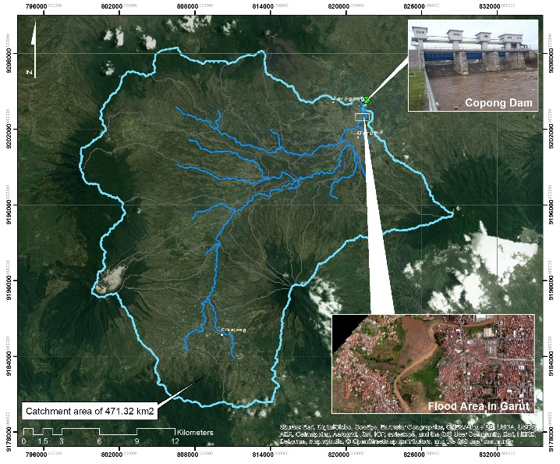

Figure 2. Catchment area with Copong Dam as downstream

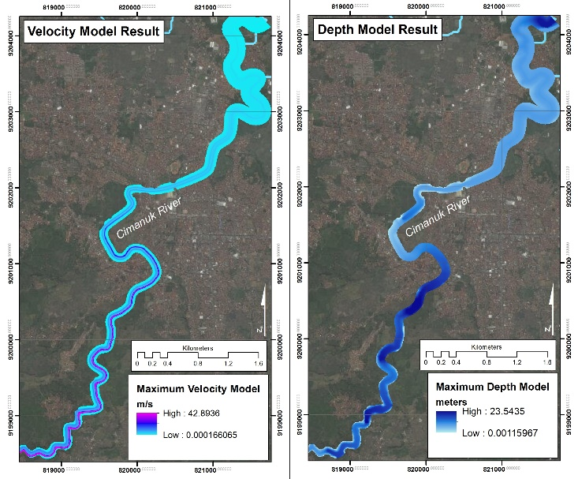

Figure 3. Flood inundation model results - velocity model (left) and depth model (right))

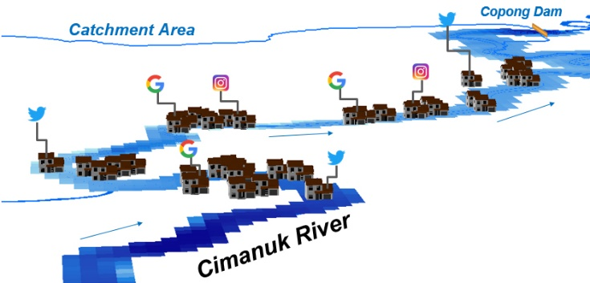

**Figure 4. Element at risk depiction of essential facilities (residents/buildings)**

|  |  |
| --- | --- |
| Collapsed | Moderately |
| Severely | Slightly |

**Figure 5. Images and level of damage classification**

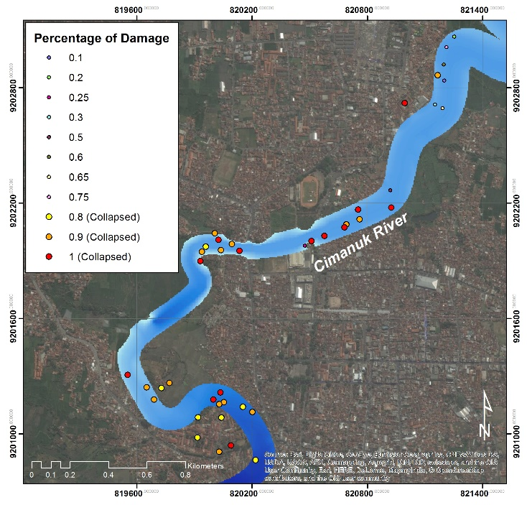

**Figure 6. Spatial depiction of the damaged residents**



Figure 7. Correlation between damage and velocity



**Figure 8. Correlation between damage and depth**