The physiochemical condition of Mangrove ecosystems in the coastal district of Sulamo, Kupang,East Nusa Tenggara, Indonesia.
Erny Poedjirahajoe^{1*} , Jeriels Matatula²

¹Department of Forest Resources Conservation, Forestry Faculty, Universitas Gadjah Mada. Jl. Agro No.1 Bulaksumur, Sleman 55281, Yogyakarta.
²Forestry Field Program, Politeknik Pertanian Negeri Kupang. Jl. Prof. Herman Johanes, Lasiana,
Kupang 85011, East Nusa Tenggara.

Abstract
The mangrove ecosystem located on the coastal district of Sulamo is experiencing a degraded condition due to the activities of fish ponds and salt ponds that occur today. As a result of the various damages that occur resulting in a decrease in the quality and quantity of mangrove environments, this provides a very alarming effect, such as increased abrasion, decreased sea yield, and sea water intrusion. Various rehabilitation effort and restoration of mangrove forest has been done but there have not been any significant results. The main reason for the various failures in this activity is that the effort is not based on scientific data or it can be said without the scientific studies conducted regarding the suitability of the physicochemical conditions of mangrove habitats along the beach coast Sulamo district. The purpose of this research is to analyze the condition of salinity, the thickness of mud and the slope of the selected mangrove locations Oeteta, Pariti, Beringin and Pitai beaches with systematic sampling methods as well as preparing maps Spatial distribution for each of the parameters. The salinity conditions show varying variations, ranging from 19 ppm to 42.33 ppm. The thickness of the mud shows the highest value at 79.11 cm and the slope of mangrove coastal 1-4%. This research shows the condition of mangrove ecosystem in the coastal district of Sulamo is still suitable for mangrove growth. This research will provide a basic overview of mangrove ecosystem conditions located on the beach coast of the Sulamo district as the basis for planning rehabilitation programmes and mangrove restorations in the research area.

Keywords: Beach slope level, mangrove habitat, mangrove forest, mud thickness, salinity level

*Correspondence author: Poedjirahajoe19@gmail.com

Introduction
Mangrove ecosystem has a very important role to be reviewed from the point of view of environmental value, biology, and Environmental Health (Baran 1999), because mangrove is a coastal ecosystem that provides the highest bioligatic productivity (Alonggi 2002) . The mangrove ecosystem has ecological functions in absorbing carbon, pollutant remediation, abrasion prevention, intrusion and Storm prevention (Wiryanto et al. 2017), while also able to function as a habitat for growth and development of aquatic fauna (Matatula et al. 2019). Mangrove is a habitat of various types of microorganisms that are tolerant of extreme environmental conditions (Retnowati et al. 2017), mangrove also provides a very important role to preserve biodiversity (Husodo et al. 2017).
The Mangrove ecosystem provides protection services for the existence of small fish, fish larva and shells of predatory attacks (Lapolo et al. 2018), this causes mangrove forests to play a significant role in coastal ecosystems including ecological, social, and economic aspects (Basyuni et al. 2018; Schaduw 2018). The mangrove ecosystem has the ability to increase fishery products up to 23% of the normal value (Anneboina & Kumar 2012), so the mangrove ecosystem is instrumental in all the coastal subtropical and tropical regions (Analyuddin et al. 2016). The current conditions of the mangrove ecosystem have degraded, as the population grows and excessive human activity on the mangrove ecosystem (Matatula et al. 2018). Various building activities such as reclamation, physical development along the coastline and pollution is the cause of degradation and the intration of the Mangrove forest ecosystem (Husodo et al, 2017). The conversion of mangrove forest to pond is one of the biggest contributors to the destruction of mangrove forest (Kunarso et al. 2015). Therefore, the management of mangrove should be done sustainably by all government institutions in an integrated (Febryano et al. 2014), by applying the appropriate social models in the management of mangrove (Sulistyorini et al. 2018).
The quality of the mangrove ecosystem is very affecting the health condition of mangrove plants, although this plant is famous for plants that have a high adaptation to the change in environmental conditions (Matatula 2017). Physiochemical conditions such as salinity, mud thickness and coastal slope are the parts of the environment factor affecting the existence of mangrove ecosystems in a place (Matatula et al. 2019). Sulamo subdistrict has mangrove forests that are located along the coast, where the mangrove forest is experiencing various pressures such as land-to-ground function into fish ponds and salt ponds. Various rehabilitation and mangrove restoration efforts have been carried out but there has been no significant results. The main reason for various failures in this activity is that these efforts are not based on scientific data or without scientific studies conducted regarding the suitability of the physicochemical conditions of mangrove habitats located along the coast District of Sulamo. The purpose of this research is to analyse the conditions of salinity, the thickness of mud and the slope of mangrove locations in the coastal district of Sulamo.

Methods
Research is conducted on the ecosystem of mangrove forests in Sulamo subdistrict (the mangrove forests of Oeteta, Pariti, Beringin Beach and Pitai). The research location can be seen in Figure 1. Research was conducted on four locations with systematic sampling methods which were systematically distributed in mangrove forests. Measurement of environmental parameters such as salinity, mud thickness and beach slope by using Transect Line method and Example Plot (Transect Line Plot).

Physicochemical analysis
Salinity is measured on each tile that is placed perpendicular to the coastline. At each research site is created pathways that penetrate the proximal zone, the medial zone and the distal zone. In each zone is created measuring plot (PU) measuring 10 m x 10 m, so the total observation plot is 825 (275 x3) Tile of 275 lanes with a distance between the lines of 50 meters (Senoaji et al. 2016). Measurement of salinity is performed with the tool of Defrakto meter. The thickness measurement of mud is done by using a 2-meter-scale stick while tilt measurement using Clinometer. Map creation of environmental conditions where it grows using salinity measurement data, mud thickness and tilt measurement data. The results of the measurement of these three environmental factors are made in the Klas-G-1: For low salinity, worth 10-20‰, G-2: For moderate salinity, valued at 21-30‰ and G-3: For the high salinity, it is worth > 30‰. Class mud thickness divided into L-1: For the thickness of mud between 10-30 cm, L-2: for the thickness of the mud 31-40 cm and L-3: For the thickness of the mud > 40 cm and for the classes of S-1 : For low tilt (almost flat), worth ≤ 1.5%, S-2: For medium slope (almost flat to ramps), is worth 1.6-3.0% and S-3: For high tilt (ramps to tilt), worth ≥ 3.0% (Poedjirahajoe 2006).

Results and Discussion
Condition of salinity mangrove ecosystem
The development of the development in each area followed by the increase of population indirectly gives the determination of the mangrove ecosystem (Matatula 2010), this happens because of various development oriented to the aspect of Economic impact on the existence of mangrove forest ecosystems. Dahuri (2003) said that development activities focused on coastal areas resulted in an impact on environmental sustainability because environmental factors strongly affect the existence of mangrove ecosystem. One of the environmental factors that is very influential for the mangrove ecosystem is salinity. According to Poedjirahajoe (2007) salinity is the content of salt content of a water that is spoken in a per mile (‰) or salt of a water per thousand. Salinity strongly affects the growth of mangrove forests and the survival of Biota in the mangrove ecosystem environment. The condition of salinity will give a maximum effect on Scylla mangrove crab serrata in connection with the process of osmoregulation of his body (Hastuti et al. 2015). Based on the results of the measurement of salinity value at the research site in Sulamo Sub-district (Oeteta, Pariti, Beringin Beach and Pitai) show different diversity. The salinity of the measurement results on coastal mangrove ecosystem of Sulamo subdistrict can be seen in Table 1, 2, and 3.
The mangrove ecosystem on the coast of Oeteta shows the characteristics of the lowest salinity value of 20 ppm and the highest at 34 ppm value, with the dominant salinity of 30 ppm and 11 values of salinity diversity (Figure 2). The characteristic of salinity with its spread shows that the mangrove ecosystem of Oeteta is entered in a salinity condition that supports mangrove growth, it is in line with said Saparinto (2007) that the mangrove can flourish in the area Estuarine with 10 ppm-30 ppm salinity. The characteristic salinity of the mangrove forest ecosystem of Oeteta is strongly influenced by rivers flowing adjacent to the mangrove forest of Oeteta. Environmental conditions are the main thing to note to keep the mangrove forest as the location of the mangrove ecosystem of Oeteta and Pariti has suffered land degradation due to fish pond activities and salt ponds, this is in line With the opinion of Husodo et al. (2017) which states that the mangrove ecosystem is a coastal ecosystem that is currently raising damage continuously in terms of extentness and quality. Poedjirahajoe (2011) also stated that, environmental factors strongly affect the composition of the mangrove ecosystem, even changes in the quality of the environment complex can result in the shifting type of vegetation constituent.
Characteristic salinity of the coastal area mangrove ecosystem Pariti shows the lowest value of 19 ppm and the highest at a value of 42,33 ppm with the dominant value of salinity 30 ppm and 28 diversity of salinity value (Figure 3). Salinity value in Pariti area is found low because some places in Pariti mangrove forest come into contact with rice fields located at the back of mangrove forest. But as a condition of salinity of the mangrove forest Pariti Show high value of this matter because the north here is no river flowing so that there is no mixing between sea water and fresh water. The salinity characteriof Sulamo subdistrict tstic of the mangrove ecosystem located in Oeteta and Pariti has similarities, where both regions have the same dominant salinity value. For the salinity of the mangrove ecosystem at Beringin beach shows a value of 20 ppm-32 ppm with a diversity value of 18 and the dominant salinity value is at 20,33ppm (Figure 4). The decline in the salinity value that occurs in the area of Beringin Beach is caused by the rear and the side of mangrove ecosystem surrounded by fish pond. Salinity of the Pariti mangrove ecosystem and the mangrove ecosystem of Beringin Beach are influenced by fresh water compounding from rice fields and fish ponds not because the river flows as in the mangrove ecosystem of Oeteta. Unlike the mangrove ecosystem of Oeteta, Pariti and Beringin beach characteristic salinity that resides in the Mangrove Pitai ecosystem shows 30,33 ppm-40 ppm, with the dominant salinity value of 30, 33 ppm and the diversity of salinity as much as 2 (Figure 5). Condition of salinity of mangrove ecosystem in Sulamo sub-district if we compare with the mangrove Ecosystem in Karang Gading Wildlife Sanctuary Lankat northeast of North Sumatra, then the value of salinity located in the Mangrove ecosystem Sulamo District has value Salinity is higher considering that the Sumatran area of the drainage value is 16,21 ppm-23, 53 ppm (Siahaan 2016). This is because in the district Sulamo is very low the estuary of rivers flowing so that there is no mixture of freshwater and seawater. Based on the fact that the salinity of the mangrove ecosystem in Sulamo sub-district proves that mangrove can grow and self-fit in existing environmental conditions, it is in line with Purnobasuki et al. (2016), stating that mangrove Can be used to build the stabilization of coastal ecosystems because mangrove is able to live on high salinity and resistant to large waves.
Condition of mud thickness mangrove ecosystem.
Mangrove forest ecosystem is a type of ecosystem located in the coastal area and regularly flooded with sea water or influenced by the tide of sea water, with muddy soil conditions, sandy or sandy mud. Mangrove ecosystem is a typical ecosystem for tropical areas, there is a muddy beach area and the water is calm. Mud is the place to grow mangrove vegetation, even the mangrove has a condition of growing like soil containing mud, sea tides and relatively small waves (Matatula 2018). The thickness of the mud is very important not only in mangrove vegetation but the life of biota that is in the mangrove ecosystem. As an example of the life of Scylla serrata biota that is always active in the mud with tide conditions and receding sea water (Widigdo 2017). Mud thickness measurement is very important known because thickness and substrate characteristics are essential to support various activities related to rehabilitation and restoration of Mangrove (Setyawan 2012). At the site of the mangrove forest ecosystem research located in the district of Sulamo shows different characteristics and diversity. The thickness of the mud is an environmental factor affecting the growth of vegetation and survival in the mangrove ecosystem. The uniqueness of mangrove forest can be seen in the habitat condition of his life, also the biodiversity flora that is capable of survival (Davinsy et al. 2015).
Conditions of thickness of mud ecosystem of the mangrove Oeteta 13, 33cm -54, 88cm, dominant thickness of mud at three values are 23,88 cm, 30 cm and 38,33 cm with a diversity of mud thickness 23 diversity (Figure 6). For the location of mangrove ecosystem of Beringin Beach has a thickness of mud 19,55 cm-58,77cm with a dominant value of mud thickness of 19, 55 cm and 6 thickness of mud diversity (Figure 7). While the forest mangrove ecosystem Pitai shows the thickness of the mud 26,55cm-37,88cm with a diversity of 7 (Figure 8). In the four locations of this research the Pariti mangrove ecosystem has the highest mud thickness where the thickness value is 17,33 cm -79,11 cm, with the dominant thickness value of 43,22cm and the thickness of mud density 132. This is in line with the statement of Noor et al. (1999) that the condition of mud thickness greatly affects the ability to rooting mangrove vegetation in capturing sediment transported by water when the water tide occurs, where the thickness of the mud will Affects the pharmaceutics a vegetation, because tree roots are able to bind and stabilize mud. If we compare the thickness of the fourth mud research site with other locations in Indonesia such as in the area of coral Ganding Langkat northeast of North Sumatra that has a mud thickness of 59, 07cm -131, 95cm (Siahaan 2016), then the thickness of the mud is Sulamo subdistrict shows more low value. This is due to the research area is very less large rivers flowing throughout the season so this affects the thickness and characteristics of mud substrates. The condition of the rocky geography becomes an integral part of the coastal mangrove ecosystem of the Sulamo subdistrict, it is in line with the opinion (Majid 2016), that the mangrove forest can grow on the Coral beach, where the coral reefs die dead On the top of which is a thin layer of sand or mud or muddy beaches. The condition of mud thickness on the beach coastal of Sulamo subdistrict mangrove ecosystem can be seen in Table 1, 2, and 3.

Condition of slope mangrove ecosystem
The mangrove ecosystem provides an important function in living creatures, but in fact human beings with various activities give threats to the existence of mangrove ecosystem (Fusion et al. 2016) so that the mangrove ecosystem suffered damage and damage could be permanent even not only happens to the structure and density but this damage also occurs in the existence of species (Astiani 2016). Therefore, understanding the condition of mangrove ecosystem such as slope of the beach becomes an important thing in various activities of rehabilitation planning or restoration that will be done against the mangrove ecosystem.
The slope of the beach in the Manngrove ecosystem of Sulamo shows a variation of slope of 1%-4% on the location of the observation. The mangrove ecosystem of Oeteta showed a slope of 1%-2% (Figure 9), Pariti 1%-4% (Figure 10), Banyan Beach 1%-3% (Figure 11) and Pitai 2%-3% (Figure 12). These four locations have the dominant value of inclination at the value of 2%, with varying grades of slope diversity in which Oeteta shows the value of diversity by 5 diversity, Pariti 8 diversity, Beringin Beach 6 diversity and Pitai 7 diversity. The slope condition in the mangrove ecosystem indicates a high slope where the slope range can reach 4%. This is very different from the slope of a mangrove forest ecosystem on the north coast of North Sumatra that has a slope carried < 2% (Kusmana 2018). Please note that slope of the coastal mangrove ecosystem has an effect on the growth of mangrove, this is due to slope and ups and downs are two interconnected, where the beach characteristics such as the Luasan, Length of the coastline is associated with winnings and sedimentation. Slope condition of the mangrove ecosystem of the Sulamo sub-district can be seen in tables 1, 2, and 3. When environmental conditions such as salinity, mud and slope of the coast support, it will be very helpful in the process of generation especially in germination of seeds such as Avecennia marina type (Hastuti et al. 2016).
Spatial distribution of environmental conditions Mangrove ecosystem
Nowadays, developing countries have damaged mangrove forest due to various human activities (Meng et al. 2016). Spatial distribution of salinity conditions, thick mud and slope in the mangrove ecosystem should be known to be the basis of planning and management of coastal areas. According to (Manurung et al. 2017) that currently the mangrove forest facing a variety of anthropogenic disorders, especially fromkness of the mud with a density of 31 cm-32 cm (slightly dark color), for thin mud conditions dominates the back. For the location of the mangrove ecosystem Pitai is dominated by a somewhat t the industrial field for it needs to be conducted environmental studies so as to get recommendations for the selection of types that match the condition An existing environment. Map of spatial distribution the condition mangrove growth in Sulamo sub-district of Kupang district became much needed because according to (Zulfikhar et al. 2017), there has been a forest fragmentation that has impacted reduction in numbers and sizes.
The spatial distribution of salinity conditions shown on the interpolated map of field-scrolling data shows that the mangrove ecosystem with high salinity dominates the front up to the middle part of the Sulamo mangrove ecosystem with The highest salinity value of 32 ppm-43,33 ppm (black color display on the map), while for salinity is dominating the front mangrove ecosystem and the central part with a salinity value of 30ppm (a slightly darker color display on the map) then followed With a low salinity that dominates the back of the mangrove ecosystem with a dominant value of 20ppm (a brighter light display). Map of salinity in the mangrove ecosystem of Sulamo subdistrict can be seen in Figure 13. Spatial distribution of mud thickness based on map shows that starting from the mangrove ecosystem of Oeteta adjacent to the Nunkurus River shows the thickness of thin with a value of 13, 33cm (light color) to a bit thick with the dominant value 38, 33cm (slightly darker color). Pariti Mangrove ecosystem shows the thick spatial thickness of the mud in the middle with a value thickness can reach 54, 88cm, while to a somewhat thick dominates the front, middle and back with the value 34,33cm while the mud Dominates the back of the rear with a range of 19 cm values. The mud thickness of Beringin beach is indicated by a spatial map of the front and center dominated by the thichick mud thickness on the front and the thickness of thin mud dominates on the back. Map of mud thickness of mangrove ecosystem Sulamo District can be seen in Figure 14. Slope of coastal mangrove ecosystem Sulamo District in dominance by a slope of 1%-4% is seen in map spatial beach slope .mangrove ecosystem that started from Oeteta with slope value dominated by 2% slope that in a spatial map drawn in a slightly dark color. For the Pariti area shows the black color that dominates most of the mangrove ecosystem area, while for the coastal area of Pantai Beringin has a value with variations from flat to ramps, this is different from the Pitai area which dominated by almost flat to ramps. Slope of the mangrove ecosystem of Sulamo Sub-district can be seen in Figure 15.

Conclusion
The mangrove ecosystem located in Sulamo subdistrict indicates salinity conditions, mud thickness and slope varying in four research locations. The salinity conditions show a value of 19 ppm-42.33 ppm. The thickness of the mud shows the highest value at 79.11 cm and the beach peisir slope 1-4%. These results indicate the environmental conditions supporting mangrove ecosistence as well as expected the results of this research to be the basis for planning the management of mangrove ecosystem in the coastal district of Sulamo.
Recommendation
It is necessary to do a further study of the community's conception of how the mangrove ecosystem for protection and community life in Sulamo district has been conducted.
Acknowledgments
We sincerely thank the Bupati of Kupang, head of Sulamo subdistrict and natural resource Conservation Hall, East Nusa Tenggara which has given us permission to conduct research. We would like to thank the mangrove Group of Kupang Agricultural Polytechnic which has been assisting in the implementation of this research. Head of District.
References
Alonggi, D. M. (2002). Present state and future of the word’s mangrove forests. environ conservation 29: 331-349.

Analuddin, K., Septiani, A., Sharma, S. & Hagihara, A. (2016). Crown shape dynamics of dense mangrove kandelia obovata stands in manko wetland, okinawa island, Japan. Biodiversitas, 17, 865-872. doi. 10.13057/biodiv/d1702xx.

Annebaina, L. R., & Kumar, K. S. K. (2012). Economic analysis of mangrove and marine fishery linkages in India. Ecosystem Service, 24: 114-123.

Astiani, D. (2016). Tropical peatland tree-species diversity altered by forest degradation. Biodiversitas. 17, 102-109. doi: 10.13057/biodiv/d170115.

Baran, E. (1999). Review of quantified relationships between mangrove and coastal resources. Puket mar bio cent res bull 62: 57-64.

Basyuni, M., K. Gultom, B. A., Fitria, I. E., Susetya, R., Wati, E., Slamet, T., Balke, P., Bunting. (2018). Diversity and habitat characteristics of macrozoobenthos in the mangrove forest of lubuk kertang village, north sumatra , Indonesia. Biodiversitas, 19, 311–317. doi. 10.13057/biodiv/d190142.

Dahuri, R. (2003). Keanekaragaman hayati laut; Aset pembanguan berkelanjutan Indonesia. Jakarta. Jakarta Gramedia Pustaka Utama.

Davinsy, R., Kustanti, A., & Hilmanto, R. (2015). Study of mangrove forest management in the pahawang island village marga punduh district pesawaran regency. Sylva Lestari, 3, 95–106.

Fabryano, I. G., Suharjito, D., Darusman, D., Kusman, K., & Hidayat, A. (2014). The roles and sustainability of lokal institutions of mangrove management in pahawang island. Tropical forest management, XX, 69-76. doi. 10.7226/jtfm.20.2.69.

Fusi, M., Bione, G. M., Suciu, N. A., Sacchi, A., Trevisan, M., Capri, E., Daffonchi, D., Din, N., Guebas, F. D., & Cannicci, S. (2016). Ecological status and sources of anthropogenic contaminants in mangroves of the wouri river estuary (Cameroon ). MPB. 109,723–733. http://dx.doi.org/10.1016/j.marpolbul.2016.06.104.
Husodo, T., Palabbi, S.D.G., Palabbi., Abdoellah, O.S., Nursaman, M., Fitriani, N., & Partasasmita, R. (2017). Short communication : Seagrass diversity and carbon sequestration : Case study on Pari Island, Jakarta Bay , Indonesia. Biodiversitas 18(4),1596–1601.doi. 10.13057/keanek/d180438.

Hastuti, Y. P., Affandi, R., Safrina, M. D., & Faturrohman, K. (2015). Optimum salinity for growth of mangrove crab Scylla serrata seed in recirculation systems. Akua Kultur Indonesia. 14, 50–57.

Hastuti, E. .D., & Budihastuti, E. (2016). Potential of mangrove seedlings for utilization in the maintenance of environmrntel quality within silvofishery ponds. Biotropia 23, 58–63. doi. 10.11598/btb.2016.23.1.606.

Kunarso, A., Tubagus, AA., Syabana., Azwar, F., & Bastoni. (2015). Mangrove rehabilitation using silvofishery system in telang protection forest, south sumatra: Opportunities and challenges. Proceedings: The International Conference of Indonesia Forestry Researchers III. Bogor, 21 −22 October 2015.

Kusmana, C., Hidayat, T., Istomo., Rusdiana. O. (2018). Growth performance of Bruguiera gymnorrhiza derived from cut- propagule seedling. Biodiversitas, 19, 208–214. doi. 10.13057/biodiv/d190128.

Lapolo, N., Utini, R., Wahyuni, D. K & Baderan. (2018). Diversity and density of crabs in degraded mangrove area at Tanjung Panjang Nature Reserve in Gorontalo , Indonesia, Biodiversitas, 19, 1154–1159. doi. 10.13057/keanek/d190128.

Majid, I., Muhdar, M. H. I., Syamsuri, I. (2016). Konservasi Hutan Mangrove Di Pesisir Pantai Kota Ternate Terintegrasi Dengan Kurikulum Sekolah. Jurnal BIOedukasi. 4(2) 488-498.

Manurung, J. et al., 2017. Genetic variation of the mangrove species Avicennia marina in heavy metal polluted estuaries of Cilegon Industrial Area, Indonesia. Biodiversitas, 18,1109–1115. doi. 10.13057/biodiv/d180331.
Matatula, J. (2010). The study of mangrove habitat quality based on at kupang gulf coastal area east nusa tenggara. (tesisi). Universitas Gadjah Mada. Yogyakarta.
Matatula, J., Pathibang, M.R., & Aryani, N. K. A. D. (2017). Kualitas Habitat Mangrove Di Pantai Tanah Merah Kabupaten Kupang. Prosiding Seminar Nasional 2 Laborantorium Riset Terpadu Undana. Hal : 24-32. Kupang.

Matatula, J., Pathibang, M. R., Aryani, N. K. A. D., & Ngaji, A. U. K. (2018). Mangrove forest habitat conditions in Tanah Merah coastal beach East Nusa Tenggara. International conference on climate change, biodiversity, food security and local knowledge. Artha Wacana Christian University. Kupang, 3-4 September 2018.

Matatula, J., Poedjirahajoe, E., Pudyatmoko, S., & Sadono, R. (2019). Spatial distribution of salinity, mud thicknessa and slope alog mangrove ecosystem of the coast of kupang district, east nusa tenggara, Indonesia. Biodiversitas, 20, 624-1632. doi. 10.13057/biodiv/d200619.

Matatula, J., Poedjirahajoe, E., Pudyatmoko, S., & Sadono, R. (2019_{b}). The spatial spread of mangrove forest environmental condition at kupang seashore. Jurnal of Natural Resources And Environmental Management, 9, 467-482. doi. http://dx.doi.org/10.29244/jpls.92 467-482.

Meng, X., Xa, P., Li, Z., & Meng, D. (2016). Mangrove degradation and response to anthropogenic disturbance in the Maowei Sea (SW China) since 1926 AD: Mangrove-derived OM and pollen. Organic Geochemistry, 98, 166–175. http://dx.doi.org/10.1016/j.orggeochem.2016.06.001.
Noor, Y. R., M. Khazali., & Suryadipura, I. N. N. (1999). Panduan Pengenalan Mangrove Indonesia. Wetlands International Indonesia Programe, Ditjen PKA, Jakarta.

Onrizal & Kusman, C. (2008). Study ecologi of mangrove forest in the east beach north sumatra. Biodiversitas. 9, 25-29.

Poedjirahajoe, E. (2006). Klasifikasil lahan potensial untuk rehabilitasi mangrove di pantai utara Jawa Tengah (Rehabilitasi mangrove menggunakan jenis Rhizopora mucronata). (Disertasi). Universitas Gadjah Mada, Yogyakarta.

Poedjirahajoe, E. (2007). Dendrogram zonasi pertumbuhan mangrove berdasarkan habitannya di kawasan rehabilitasi pantai utara jawa tengah bagian barat. Jurnal Ilmu Kehutanan, I, (2):10–21.

Poedjirahajoe, E., Widyorini, R., & Mahayani, N. P. D. (2011). Kajian ekosistem mangrove hasil rehabilitasi pada berbagai tahun tanam untuk estimasi kandungan ekstrak tanin di pantai utara jawa tenggah, Jurnal Ilmu Kehutanan, V, 99–107.

Purnobasuki, H., & Utami, E. S.W. (2016). Seed germination of Avicennia marina (Forsk.) vierh. By pericarp removal treatment. Biotropia, 23,74-83. doi. 10.11598/btb.2016.23.2.346.

Retnowati, Y., Sembiring, L., Moeljopawiro, S., Djohan, TS., & Soetarto, E. S. (2017). Diversity of antibiotic-producing actinomycetes in mangrove forest of torosiaje , Gorontalo , Indonesia. Biodiversitas, 18, 1453–1461. doi. 10.13057/biodiv/d180322.

Saparinto, C. (2007), Pendayagunaan ekosistem mangrove. effhar offset semarang, Indonesia.

Senoaji, G., Hidayat, F., Kehutanan, J., Bengkulu, U., Raya, J. & Limun, K. (2016). Peran ekosistem mangrove di pesisir kota bengkulu dalam mitigasi pemanasan global melalu penyimpanan karbon. Jurnal Manusia dan Lingkungan, 23, 327–333.

Setyawan, A., Ulumuddin, Y. I. (2012). Species diversity of Rhizophora in tambelan island, natuna sea, indonesia. Biodiversitas. 13, 172-177. doi. 10.13057/biodiv/d130402.

Schaduw, J. N. W. (2018). Distribusi kualitas perairan ekosistem mangrove pulau kecil taman nasional bunaken. Majalah geografi indonesia, 32, 40-49. doi. http://doi.org/10.22146/mgi.32204.

Siahaan, H. D. M. (2016). Ecological mangrove habitat in encroachment area of palm oil plantation in wildlife preserve area of karang gading langkat timur laut, nort sumatra. (tesisi). Universitas Gadjah Mada. Yogyakarta.

Sulistyorini, I. S., Poedjirahajoe, E., Faida, L. R. W., & Purwanto, R. H. (2018). Social capital in mangrove utilization for silvofishery: Case study in kutai national park, Indonesia. Tropical forest management, 20, 60-69. doi. 10.7226/jtfm.24.2.60.

Wiryanto., Sunarto., & Rahayu, S.M. (2017). Biodiversity of mangrove aquatic fauna in Purworejo , Central Java , Indonesia. Biodiversitas, 18,1344 –1352. DOI : 10.13057/biodiv/d1180309.

Zulfikhar., Zulkiflih, H., Kadir, S., & Iskandar I. (2017). The landscape structure change of the tropical low forest and its possible effec on tree species diversity in south sumatra, Indonesia. Biodiversitas, 18, 916–927. doi. 10.13057/biodiv/d180308.

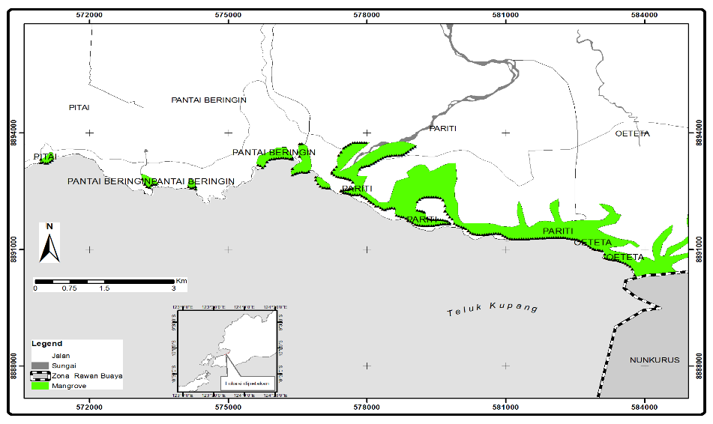
Figure 1. Map showing the mangrove research locations along the coastal area of Sulamo
subdistrict, East Nusa Tenggara, Indonesia.

Figure 2. Variation in salinity along sampling lines of Oeteta mangrove location

Figure 3. Variation in salinity along sampling lines of Pariti mangrove location

Figure 4. Variation in salinity along sampling lines of Pitai mangrove location

Figure 5. Mud thickness variation in different sampling lines of Oeteta mangrove location

Figure 6. Mud thickness variation in different sampling lines of Pariti mangrove location

Figure 7. Mud thickness variation in different sampling lines of Pantai Beringin mangrove location

Figure 8. Mud thickness variation in different sampling lines of Pitai mangrove location

Figure 9. Costal slope variation in sampling lines of Oeteta mangrove location

Figure 10. Costal slope variation in sampling lines of Pariti mangrove locaton

Figure 11. Costal slope variation in sampling lines of Pariti mangrove location

Figure 12. Costal slope variation in sampling lines of Pitai mangrove locaton

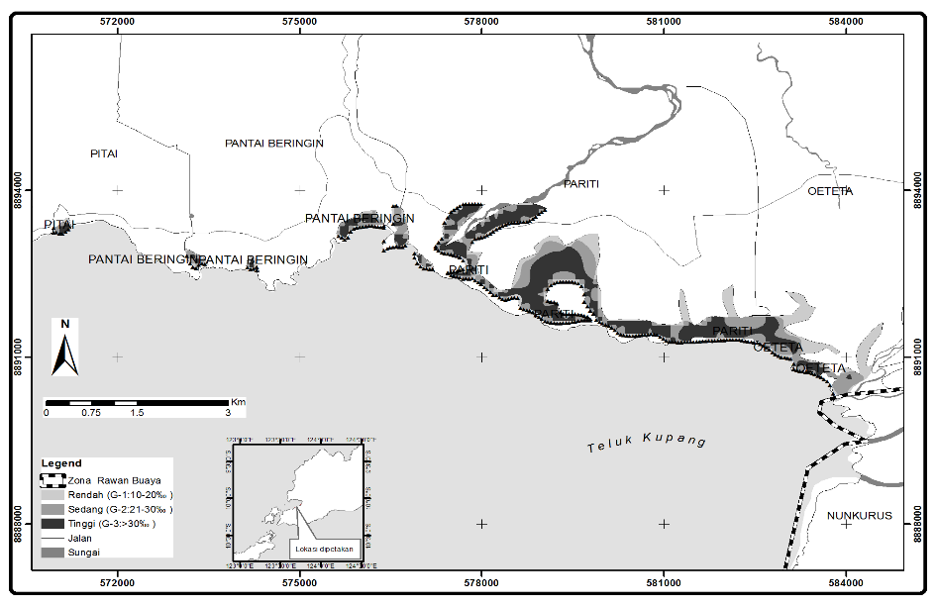

Figure 13. Map showing the distribution of salinity levels in the mangrove location of
Sulamo subdistrict, Kupang District,East Nusa Tenggara, Indonesia.

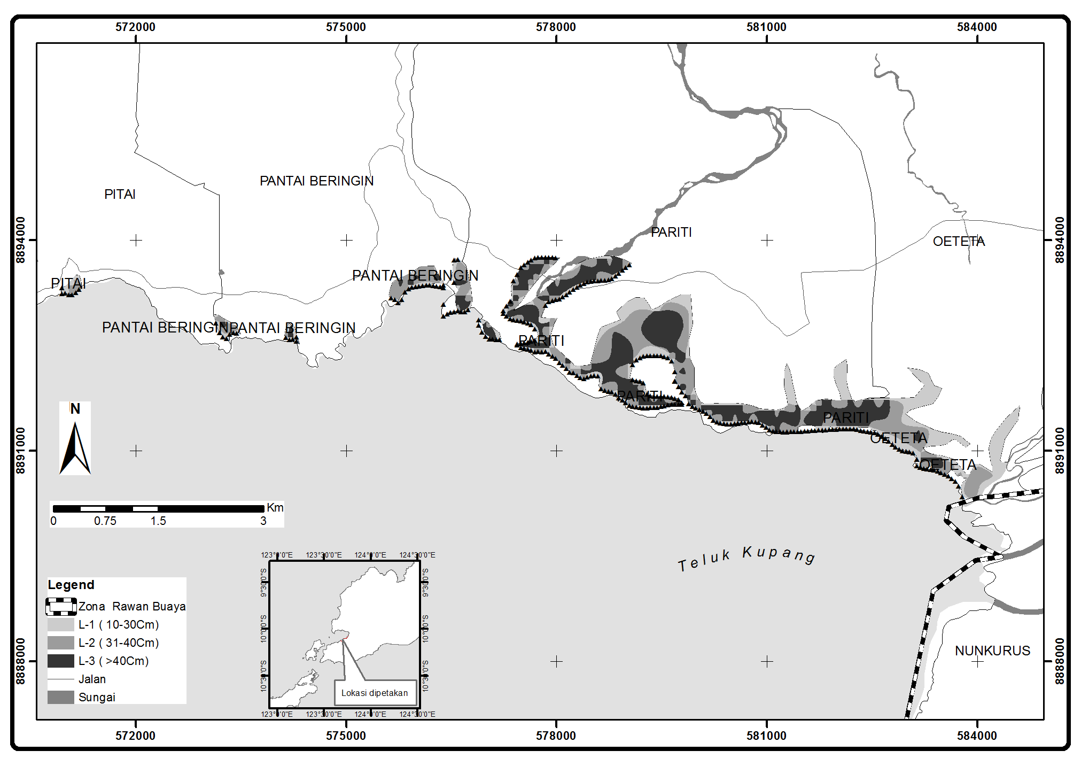
Figure 14. Map showing the distribution of mud thickness in the mangrove location of Sulamo
subdistrict,Kupang Distric, East Nusa Tenggara, Indonesia

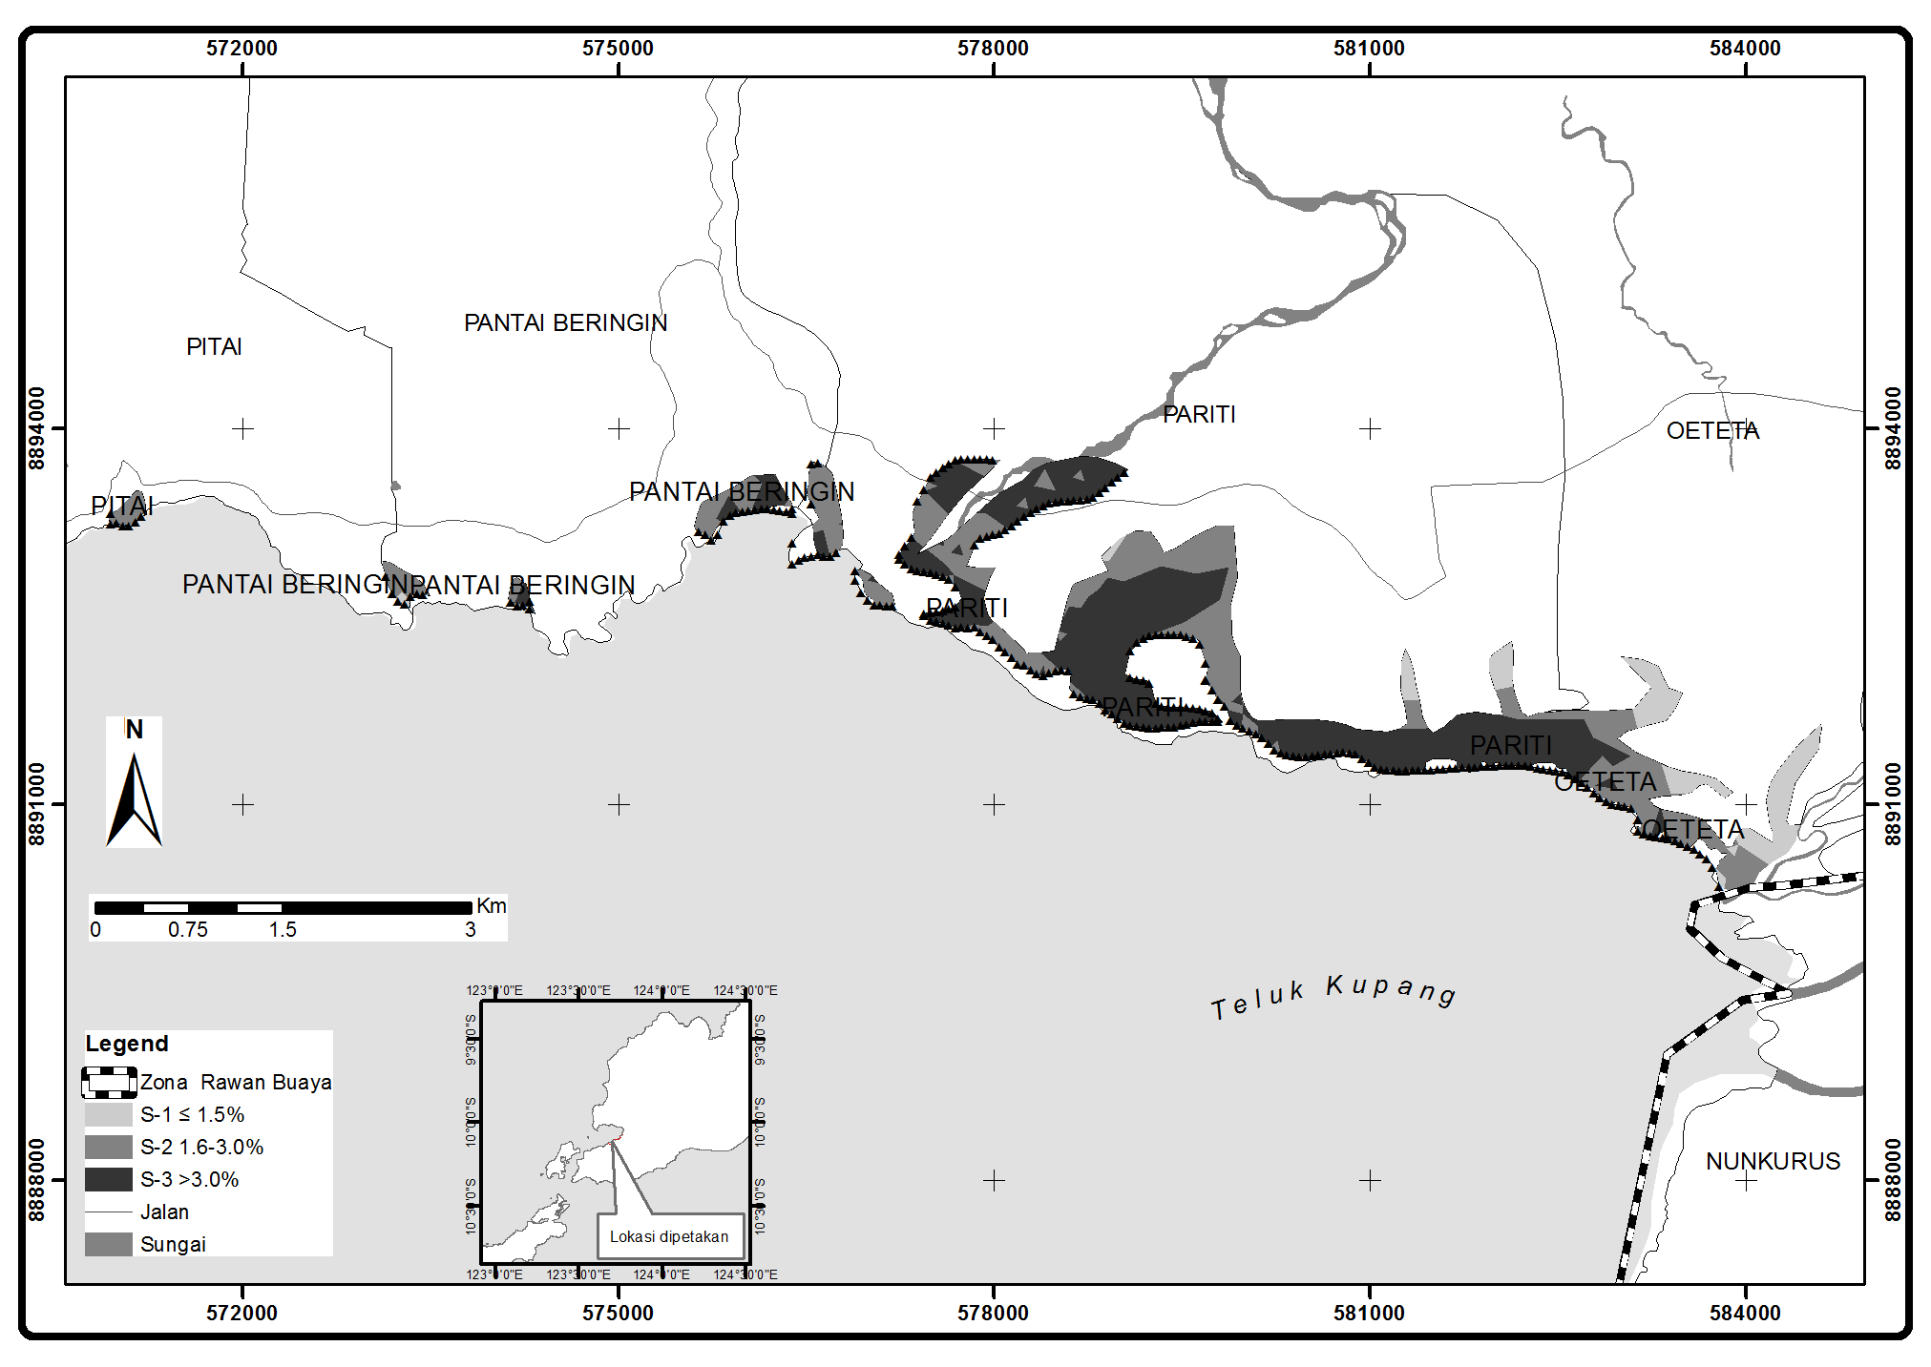
Figure 15. Map showing the distribution of slope in the mangrove location of Sulamo subdistrict,
Kupang District, East Nusa Tenggara, Indonesia.

Table 1. Salinty, mud thickness and slope values at different sampling lines of Oeteta mangrove location, Sulamo subdistrict ,Kupang District, East Nusa Tenggara Timur, Indonesia

Salinity  (ppm) | Thickness of mud (cm) | Slope  (%) | Salinity  (ppm) | Thickness of mud (cm) | Slope  (%)
23.66 | 29.11 | 2 | 24 | 54.88 | 2
30 | 14.66 | 2 | 20.66 | 32.33 | 2
30 | 14.11 | 2 | 20 | 38.66 | 2
20.33 | 13.33 | 2 | 20 | 33.66 | 2
23.66 | 18.44 | 1.33 | 30 | 29.55 | 2
20.33 | 32.77 | 1.66 | 23.33 | 27.88 | 2
23 | 38.33 | 1 | 23.33 | 17.44 | 2
20 | 38.33 | 1 | 34.33 | 15.77 | 2
30 | 23.88 | 1.33 | 30.66 | 13.55 | 2
30 | 23.88 | 1 | 24 | 17.66 | 1.66
21 | 23.22 | 1.33 | 20 | 22 | 1.66
20.33 | 53.22 | 1 | 23 | 30 | 1.33
20.33 | 47.22 | 1.66 | 21 | 30 | 1.66

Table 2. Salinty, mud thickness and slope values at different sampling lines of Pariti mangrove location, Sulamo subdistrict, Kupang District, East Nusa Tenggara Timur, Indonesia.
Salinity  (ppm) | Thickness of mud (cm) | Slope  (%) | Salinity  (ppm) | Thickness of mud (cm) | Slope  (%) | Salinity  (ppm) | Thickness of mud (cm) | Slope  (%) | Salinity  (ppm) | Thickness of mud (cm) | Slope  (%)
21.66 | 31.55 | 2 | 19.33 | 55.55 | 3 | 35 | 43.22 | 3 | 34.66 | 43.22 | 2.66
26.66 | 39.88 | 2 | 19 | 55.88 | 3 | 35 | 44.88 | 3 | 34.66 | 47.66 | 2.66
25 | 39.88 | 2 | 20 | 50.11 | 2 | 35 | 43.11 | 2.66 | 35 | 44.55 | 3
21.66 | 32.55 | 2 | 20 | 43.77 | 2 | 35 | 43.88 | 2.66 | 35 | 43 | 2.66
27 | 33.66 | 2 | 20 | 48.77 | 2 | 34 | 47.55 | 3 | 35 | 45.55 | 2
25.33 | 33.66 | 2 | 19 | 47.22 | 2 | 34 | 43.22 | 2.66 | 35 | 41.66 | 2
31.66 | 39.11 | 2 | 20 | 46.44 | 2 | 34 | 45.66 | 2.66 | 35 | 46.77 | 2
31.66 | 32.11 | 2 | 20 | 30.33 | 4 | 34.33 | 41 | 2.66 | 35 | 48.66 | 2
31.66 | 38 | 3 | 20 | 30 | 4 | 34.33 | 47.22 | 2 | 34.33 | 43.55 | 2
32.33 | 38 | 3 | 19 | 29.66 | 4 | 34.33 | 45.88 | 2 | 34.33 | 47.33 | 2
39.66 | 39.88 | 3 | 20 | 30 | 4 | 34.33 | 43.44 | 2 | 34.33 | 44.55 | 2.33
41.33 | 39.11 | 3 | 20 | 29 | 4 | 34 | 42 | 2 | 34 | 45 | 2.33
42.33 | 32.11 | 3 | 25 | 30 | 3 | 34 | 43.11 | 2 | 34 | 42.11 | 2.33
36 | 29.77 | 2 | 20 | 30.33 | 2 | 34.33 | 43.22 | 2 | 34 | 45 | 2.33
36 | 23.44 | 3 | 25 | 28 | 2 | 34.33 | 42.44 | 2 | 34 | 46.66 | 2.33
40 | 29.77 | 3 | 30 | 28 | 2 | 34.33 | 42 | 2 | 34 | 46 | 2.33
25 | 29.77 | 2 | 30 | 26 | 2 | 34.33 | 47.55 | 2 | 34 | 46 | 2.33
25 | 29.77 | 2 | 30 | 24.33 | 2 | 34.33 | 42.11 | 2 | 35 | 44.55 | 2.33
23 | 29.88 | 2 | 30 | 27.66 | 2 | 34.33 | 43 | 2 | 35 | 41.55 | 2.33
25 | 23.44 | 2 | 30 | 54.66 | 1 | 34.33 | 44.66 | 2 | 35 | 45.11 | 2
24.33 | 29.77 | 2 | 30 | 56.33 | 1 | 34.33 | 44.66 | 2 | 35 | 46.22 | 2
24 | 54.44 | 2 | 30 | 54.66 | 1 | 34.33 | 46.22 | 2 | 35 | 44.44 | 2
25 | 71.11 | 2 | 30 | 70.66 | 1 | 34.33 | 44.66 | 3 | 35 | 44.66 | 2
26.33 | 69.88 | 2 | 30 | 44.33 | 1 | 34.33 | 45.44 | 3 | 35 | 44.77 | 2
24.33 | 63.11 | 2 | 30 | 54.66 | 1 | 34.33 | 47.88 | 3 | 34 | 44.77 | 2
24.66 | 77.11 | 2 | 30 | 40.33 | 1 | 34.33 | 42.44 | 3 | 35 | 44.44 | 1.33
25 | 72.11 | 2 | 35 | 39 | 3 | 34.33 | 42.22 | 2.66 | 35 | 44 | 1.33
25 | 53.11 | 2 | 35 | 38 | 4 | 34 | 43.44 | 2.66 | 35 | 42.22 | 1.33
25 | 54.66 | 2 | 35 | 39 | 4 | 35 | 44.55 | 2.66 | 35 | 43.44 | 1.33
25 | 38.66 | 2.33 | 35 | 39.33 | 4 | 34.66 | 42.66 | 2.66 | 34 | 43.88 | 1.66
25 | 56 | 2.33 | 35 | 24 | 4 | 34.66 | 42.55 | 2.66 | 34 | 43.22 | 1.66
26 | 41.55 | 2.33 | 35 | 29 | 4 | 34.66 | 45.55 | 2.66 | 34 | 43.88 | 1.66
24.33 | 66.88 | 2.33 | 30 | 18.33 | 1 | 35 | 41.66 | 2.66 | 34 | 42.33 | 1
24.33 | 40.66 | 2.33 | 30 | 17.33 | 1 | 35 | 44.22 | 2.66 | 34 | 46.22 | 1.33
24.33 | 58 | 2.33 | 30 | 24 | 1 | 35 | 41.11 | 3 | 34 | 44.88 | 1.33
24 | 71.77 | 2.33 | 30 | 18.66 | 1 | 35 | 42.66 | 3 | 34 | 42.33 | 1.33
24 | 42.88 | 2.33 | 30 | 37.66 | 1 | 35 | 42.66 | 3 | 34 | 47 | 1.33
24 | 62.66 | 2.66 | 27.66 | 79.11 | 2 | 35 | 41.55 | 3 | 34 | 44.77 | 1.33
24 | 51.55 | 2.66 | 27.66 | 74.66 | 2 | 40 | 43.88 | 3 | 34 | 48.33 | 1
24.33 | 44.88 | 2.66 | 30 | 67.55 | 2 | 40 | 44.11 | 3 | 35 | 49 | 1
24.33 | 53.55 | 3 | 35 | 69.11 | 2 | 34 | 45.88 | 3 | 35 | 46.33 | 1
24 | 46.33 | 2.66 | 40 | 57.77 | 1 | 34 | 44.44 | 3 | 35 | 47.44 | 1
24.66 | 56.77 | 2.66 | 40 | 33.66 | 1 | 34 | 45.11 | 2.66 | 34.66 | 48.11 | 1
24.66 | 53.77 | 2.66 | 40 | 33.88 | 1 | 34 | 43.44 | 2.66 | 35 | 40.55 | 1
24.33 | 47.11 | 2.66 | 40 | 35.66 | 1 | 34 | 44.11 | 2.66 | 35 | 45.11 | 1
24.33 | 48 | 3 | 34.66 | 36.33 | 1 | 34 | 44.11 | 2.66 | 35 | 45.22 | 1
24.33 | 53.55 | 3 | 35 | 42 | 3 | 34 | 46.11 | 2.66 | 34.66 | 46.77 | 1
19.66 | 54.77 | 3 | 35 | 42 | 3 | 34 | 44.66 | 2.66 | 34.66 | 47 | 1
19 | 55.55 | 3 | 35 | 67.55 | 3 | 34 | 46.77 | 2.66 | 34.33 | 47.44 | 1.33
19.66 | 53.44 | 3 | 34.33 | 42.11 | 2.33 | 34.33 | 43.77 | 2.66 | 34 | 43.33 | 1
19.33 | 50.11 | 3 | 34.66 | 43.44 | 2 | 34.66 | 45.66 | 3 | 34 | 49.88 | 1
19 | 53.77 | 3 | 35 | 44.33 | 2.66 | 34.66 | 45.11 | 3 | 34 | 48.55 | 1
19 | 53.77 | 3 | 35 | 47.22 | 2.66 | 34.66 | 45.22 | 2.66 | - | - | -

Table 3. Salinty, mud thickness and slope values at different sampling lines of Pantai Beringin mangrove location, Sulamo subdistrict ,Kupang District, East Nusa Tenggara Timur, Indonesia.

Salinity  (ppm) | Thickness of mud (cm) | Slope  (%) | Salinity  (ppm) | Thickness of mud (cm) | Slope  (%)
20.66 | 56.55 | 3 | 26.66 | 37.66 | 1
20.66 | 58.77 | 3 | 20.66 | 38.66 | 1.66
21.66 | 56.55 | 2.33 | 20.33 | 40 | 2.33
27.33 | 47.55 | 2 | 22 | 37.66 | 2
27.33 | 28.55 | 2 | 27.66 | 48.66 | 2
25 | 20.33 | 2 | 30 | 50 | 2
20.33 | 26.88 | 2 | 28.33 | 48 | 2
24 | 22.77 | 3 | 23.66 | 53 | 2
20.33 | 27.33 | 3 | 24 | 50 | 2
24 | 23.55 | 2 | 20 | 27.55 | 2
26 | 20.33 | 1 | 30 | 19.55 | 2
30 | 28.55 | 1.33 | 31 | 19.55 | 2
31 | 27.33 | 1 | 30.66 | 19.55 | 2
26.66 | 24.55 | 1 | 31 | 20.44 | 2
25.33 | 35.55 | 1 | 32 | 25.11 | 2
20.33 | 40 | 1 | - | - | -

Tabel 4. Salinty, mud thickness and slope values at different sampling lines of Pitai mangrove location, Sulamo subdistrict,Kupang District, Eas Nusa Tenggara Timur, Indonesia.

Salinity  (ppm) | Thickness of mud (cm) | Slope  (%)
32.33 | 29.88 | 2.33
40 | 26.55 | 2.66
33 | 30.88 | 3
38.33 | 37.88 | 2
30.33 | 35.55 | 3
33.33 | 37.66 | 2
30.33 | 31.55 | 2

